Texas School for the Blind and Visually Impaired
Outreach Programs
www.tsbvi.edu | 512-454-8631 | 1100 W. 45th St. | Austin, Texas 78756

Step-by-Step Guide to Reinforcing
Pre-Driver Readiness Skills with
Novice Bioptic Driving Candidates

Developed by Chuck Huss, Driver Rehabilitation Specialist
WV Bioptic Driving Program, WV Division of Rehabilitation Services
chuck.P.huss@wv.gov

Developed for
Texas School for the Blind & Visually Impaired
Outreach Programs

Table of Contents
Step-by-Step Guide to Reinforcing Pre-Driver Readiness Skills with Novice Bioptic Driving Candidate 3
Pre-Driver Readiness Skills 4
Basic Bioptic Usage Skills 14
Appendix A Functional Visual Acuity Terms* 22
Appendix B Functional Visual Field Terms* 23

Step-by-Step Guide to Reinforcing Pre-Driver Readiness Skills with Novice Bioptic Driving Candidate

Chuck Huss, COMS

WV Bioptic Driving Program

WV Division of Rehabilitation Services

#10 McJunkin Road

Nitro, WV 25143

TEL: 304-760-7149 (o)

FAX: 304-759-2264 (o)

E-MAIL: chuck.P.huss@wv.gov

ABSTRACT: Forty-eight (48) States currently permit persons with mild to moderate levels of central vision loss to apply for driving privileges with a bioptic lens system. At least half of those States require participation and satisfactory completion of some type of formalized low vision driver education training as a requirement for driver licensure. This handout will address pre-driver readiness skills; those skills needed to better prepare prospective bioptic candidates for driver licensure and reduce the cost of related adaptive driver education services. Special emphasis will be directed towards information and suggested passenger-in-car exercises dealing with distance viewing skills, critical object awareness skills, bioptic usage skills and hazard perception skills that parents, teachers and rehabilitation professionals can use to assist novice bioptic users to prepare for and explore the driving privilege.

Pre-Driver Readiness Skills

Prior to driver evaluation or driver training procedures in-car, low vision students who qualify visually and wish to explore the driving privilege should first be exposed to and able to illustrate the following basic survival low vision orientation and mobility skills (on-foot) with a reasonable degree of confidence and safety under the auspices of a certified orientation and mobility specialist:
- Receive, retain, and follow route instructions
- Mental mapping skills
- Conceptual development
a. Block Distance
- Street marker
- Street continuity
- Route shape
- Compass Directions
- Reverse vs. alternate routes
- Travel a designated path or route (and respective reverse and alternate routes) in a variety of environmental settings
1. Eye lead
    - Scanning ability
3. Textural and gradient change awareness
4. Object avoidance
5. Static and dynamic orientation
- Detect, identify, and react in time to critical objects or critical present in various travel environments
- Functional visual acuity abilities (see Appendix A)
- Awareness acuity
- Identification acuity
- Sure acuity
- Functional visual field abilities (See Appendix B)
- Static visual field
- Dynamic visual field
- Preferred visual field
- Detect, analyze, and cross intersections (stop sign and traffic light controlled)
- Scanning ability
- Conceptual development
  - Shape
  - Traffic control devices
  - Parallel versus perpendicular
- Method, safety and confidence in street crossings
- Object, speed and depth perception
- Color identification and discrimination
- Turn Right or Left on Red Laws

Distance Viewing Skills
Once the above basic survival low vision orientation and mobility skills (on-foot) are achieved with a reasonable degree of confidence and safety, it is then appropriate to begin introducing and reinforcing the following distance viewing skills with student as a front seat passenger-in-car. The reason the latter skills are important is that in the future, such skills will be used approximately 90-95 per cent of the total driving time (incorporating one’s reduced mild to moderate levels of remaining central vision abilities, along with the all-important and available para-central and peripheral fields of view). By pre-driver training’s end, the novice bioptic driver student will have a better idea of where and how to look, what to look for, and additional accommodation that can be used during certain circumstances to increase one’s margin of safety while driving.

Forward scanning skills (or so called “eye lead time/distance”: 10 -20 seconds ahead)
- Refers to your line of sight down your roadway
- The faster you are traveling, the farther down your roadway you must direct your line of sight to maintain a straight line of travel or stay within your designated travel lane or space.
- For example in residential settings and at residential driving speeds, the latter would be a one to two blocks in length viewing distance; in commercial driving environments (35 mph), eye lead time would be extended to 100+ yards or further; in secondary highway and/or interstate settings, eye lead would extend to ½ mile to 2 mile in length eye lead distances, etc.

Outdoors (sample passenger-in-car exercise):
- While driving a prescribed route of travel (through a variety of environmental settings and roadways) have student look ahead as far as possible, and advise instructor of the presence of curves, dips, hills, etc. (areas presenting restricted sight distances) roadway narrow ahead or narrow bridge warning symbol signs or pavement markings etc.

Head and eye scanning skills (building line to building line)
- Equally important to eye lead time/distance is lateral or horizontal head and eye scanning.
- It is suggested that limits of such scanning extend beyond the confines of the roadway itself.
- For example, in a residential area scanning should be from the front entrance of a home on one side of the street to the other side; in a commercial area, the latter should be from building entrance on one side to the other; in a rural area, from barn to barn on both sides of the roadway, etc.
- The emphasis being able to detect, identify and begin reacting to potential threats before such threat enters your intended path of travel
- Remember, there are only two (2) basic tasks that you can undertake with the major controls (i.e. accelerator, brake, steering wheel) of your vehicle while driving; the latter included adjustments in speed and lane position.

Outdoors (sample passenger-in-car exercise):
While traveling through a small or medium business area, especially hospital settings (especially near the noon hour) have student state aloud or point out as quickly as possible the presence of other road users approaching or crossing your path of travel.

Following distance skills (4 seconds)
- Refers to the linear distance (in seconds of time) that you should attempt to establish and maintain your vehicle from the vehicle ahead of you in traffic formation to reduce the possibility of hazard or collision

Outdoors (sample passenger-in-car exercise):
While traveling a prescribed route behind another vehicle*, have student select a stationary object along-side of the road (for example, a telephone pole or a large tree) and begin counting slowly in seconds of time when the end of the vehicle ahead passes such object until the front end of your vehicle passes same said object (for example, count 1000-1, 1000-2, 1000-3, 1000-4) to estimate the time or distance equivalent between the vehicle ahead * and the front end of your vehicle.
* When following a truck or van, follow no closer than the distance that allows you to detect the side view mirrors of such vehicle simultaneously. Remember, if you cannot see the side mirrors of the latter vehicle at the same time, the operator of that vehicle can not see you!

Collision avoidance skills
- Refers to how and what the driver should do to reduce hazard or avoid a collision
- Examples of what to do would include: steering left or right, break and hold, or in some instances using acceleration
- Remember: never steer left unless you have ample line of sight to that lane and that lane is clear of other road users (head-on collisions can be fatal)

Outdoors (sample passenger-in-car exercise):
Drive thru various environmental settings. Look ahead as far as possible. Comment on other road users that approach, enter or cross your path of travel (i.e. those on 2 or more feet, those on 2 or more wheels, those that move slowly, are poorly contrasted or need more space because of a wide turning radius). Comment on their presence on or in addition to side roads (t-left, t-right).

Communication skills
- Refers to how we make other drivers aware of our presence or intentions
- Methods that drivers can employ include the use of head lights, horn and turn indicators
- Remember on merges, the driver merging should be requesting permission to enter to other motor vehicle operators already on such roadway (not watch out, here I come!)

Outdoors (sample passenger-in-car exercise):
Drive thru various environmental settings. Stress eye lead, eye scanning and adequate following distance. Be on the lookout for oncoming turning vehicles, vehicles pulling out (implied stop scenarios), and backing vehicles, etc.

Critical Object and Condition Awareness Skills
Once a novice driver learns where and how to direct their line of sight during the dynamics of driving, he/she must learn what is important to look for in order to drive safely. Those objects/forms and conditions are commonly referred to as “critical objects or conditions”. Doron Corporation, a major manufacturer of audio-visual driver education training materials and driver education simulators, defines critical objects or conditions as “any object or condition which can be predicted to cause drivers to modify their vehicle’s speed, lane position or planned path of travel”. Three general categories of critical objects include: roadway characteristics, roadway users and traffic control devices.
The importance of critical object awareness is that its early detection and identification facilitates decision making for the driver. As a result, it affords drivers an increased margin of safety (time and/or distance needed to modify one’s speed, lane position or both to critical objects or conditions within or approaching one’s path of travel). In addition it reduces the possibility of hazard or collision and can at times compensate for the driving errors of other road users. These skills can be integrated with distance viewing skills and hazard perception skills (to be discussed later) to further facilitate safe driving practices.
The following is a breakdown of the different types of critical objects or conditions per general category:
- Roadway Characteristics:
- Roadway itself
- Presence or absence of a road shoulder
- Number of lanes
- Curbs
- Cement or other medians, peers or columns
- Curves, dips, hills, slants/tilts, camber
- Surface conditions
- Visibility
- Grade
- Road re-surfacing (lift)
- Pot holes
- Intersections
- Fixed hazards within, alongside of or near the roadway inhibiting sight distance of drivers such as:
  - Shrubs, hedges or trees
  - Hillsides or gradient of land
  - Road signs
  - Telephone or utility poles
  - Traffic control boxes
  - Commercial establishments and signs
  - Narrow bridges, tunnels, low clearance areas
- Traffic Control Devices:
- Pavement markings
- Road delineators
- Speed bumps, attenuators
- Traffic lights
- Crosswalk lights
- Road signs
  - Regulatory
  - Warning
  - Guide
  - Service
  - Construction
  - Recreation
- School guard
- Law officer
- Construction markings
- Construction barrels
- Construction cones
- Worker holding portable stop/slow sign or warning flag
- Portable signs/digital displays
- Roadway Users:
- Anyone or anything on 2 feet or 4 feet
- Anyone or anything on 2 or more wheels
- Road kill
- Road debris

Outdoors (sample passenger-in-car critical object/condition awareness skill exercises):

Stationary large in size critical objects from moving positions
Have student look as far down the roadway as possible, scanning left and right and practice detecting and verbalizing the presence of larger in size distantly positioned roadway characteristics and traffic control devices.
- For example, for the initial 10-15 minutes have student detect as many various shaped intersections, hills, blind curves, dips in the road as possible);
- For the next 10-15 minute period, have student state aloud the number of lanes and direction of flow of actual or potential traffic, including that as you are about to leave one roadway and enter another (one more lane of potential traffic than the number of sets of pavement markings present).

Large in size moving critical objects from stationary and moving positions
Again have student passenger look as far down the roadway as possible, scanning left and right and practice detecting and verbalizing the presence of larger in size distantly positioned road users such as trucks and buses that approach, enter or leave their shared path of travel or roadway.
- Emphasize the slower acceleration rate and wide turning radius (and subsequent extra time and space needed) by such road users for joining and leaving traffic formations than smaller in size vehicles).

Smaller in size stationary and moving critical objects from moving positions
Again have student look as far down the roadway as possible, scanning left and right; yet practice detecting and verbalizing the presence of smaller in size distantly positioned roadway characteristics (such as cement columns or barriers, narrow roadway underpasses), traffic control devices (construction worker directing traffic, road signs, traffic lights) and other road users (cars, pedestrians, animals).
A route of travel through a roadway construction area, narrow railroad underpass, college campus (at class change), small town business area or shopping center or mall (during peak shopping or business hours) serve as excellent lesson sites for such teaching purposes.
- During the above exercise, incorporate the concept of a “collision trap”. The characteristics of a collision trap are:
- The presence of two or more critical objects
- The driver’s path of travel is threatened by one or more critical objects
- The trap is sprung
- Quiz student on how to use adjustments in speed and lane position to avoid potential collision traps.
- As before, incorporate the use of vertical spotting techniques (to be discussed later) through the telescopic portion of the student’s bioptic lens system as needed.

Advanced critical object or condition awareness exercise No.1
Once student illustrates being able to detect and differentiate all three (3) types of critical objects or conditions quickly and consistently, introduce the following type of critical object or condition awareness exercise that all drivers must eventually become competent in using for collision avoidance purposes and safe motor vehicle operation.
- Select and approach traffic light controlled intersections amidst a variety of different driving environments (especially those that present different traffic patterns on one street v. the other).
- Quiz student on the various ways that he/she can determine the traffic pattern when approaching a cross street presenting a one-way traffic flow. For example, one might use:
- The presence or absence of traffic lights, stop line (and its contact points to longitudinal pavement markings or curb surfaces), or color, location and pattern of white longitudinal line(s) on one vs. both sides to identify the correct directional flow of traffic on a one-way street.
- The location or position of moving traffic, parked vehicles or road signs (except prohibitory type of regulatory signs) to identify traffic flow on a one-way cross street.

Advanced critical object or condition awareness exercise No. 2

Select a plus shaped traffic light controlled intersection * that presents:
- Two-way traffic patterns from three different directional sides
- One way traffic pattern from the remaining directional side.
Approach the intersection from all four basic compass directions; approach the one-way controlled street last
The intersection selected should be one that allows you to later view and discuss the shape, pavement markings and road signs present at or near such intersection from an elevated viewpoint (i.e. from an adjacent parking lot area)
From the latter elevated location, quiz student on the various critical objects that he/she can detect to determine the presence of a one way street.
Answers may include the detected presence of:
- White painted stop line extending across the street
- White solid longitudinal pavement markings separating lanes of traffic
- Do Not Enter and Wrong Way regulatory road signs
- No Right Turn or No Left Turn regulatory symbol signs
- Right and/or Left Turn Only regulatory signs
- Yellow painted longitudinal pavement marking on the right side of the roadway, near curb when facing one-way traffic
- All traffic facing same direction on approach to intersection
- Traffic in the far left lane facing the intersection

Basic Bioptic Usage Skills
Using a special accommodative optical low vision device called a bioptic telescopic lens system (more commonly known as a bioptic), a novice low vision driver can learn to expand where, how and what to look for in the driving scene under certain driving conditions that will be discussed below.

A. Definition of bioptic telescopic lens system:
A bioptic is a combination two-lens optical system with a telescope(s) attached to a pair of glasses, above one’s normal line of sight (see sample bioptic lens system below). These devices are prescription in nature and available through an optometrist or ophthalmologist who practices clinical low vision. These optical low vision aids are available in a number of different styles, sizes and powers. The most common telescopic units used for driving purposes range from 2.0X - 5.5X (“X” referring to the strength or power of magnification of the telescopic lens unit).
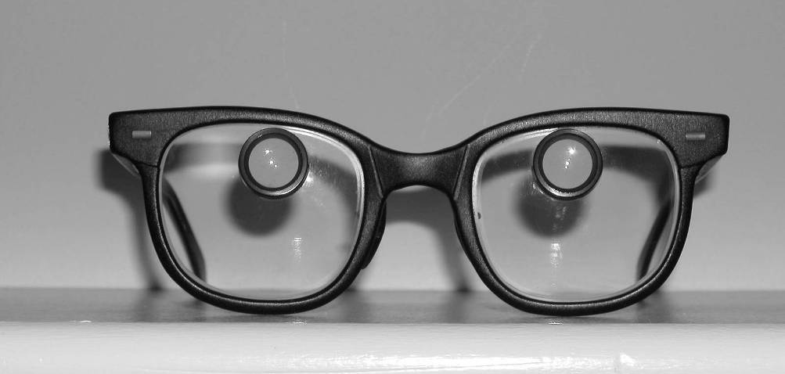
Figure 1 Bioptic Glasses
The photo in Figure 1 reveals a frontal view of an older yet still widely used Designs For Vision (DVI), Inc. (Ronkonkoma, NY) 2.2X, Galilean BIO II bioptic telescopic lens system in a standard black yeoman frame (note the physical location of the telescopic units, which are above the normal viewing area through the carrier or support lenses).

B. How are bioptics used during the driving task?
Persons using bioptic lens systems look through the larger or standard carrier lenses for general driving purposes 90-95 percent of the total driving time; and dip down into the miniature telescopic lens unit(s) using a simple synchronized head and eye vertical drop technique to discern detail, color or activity as illustrated below. This type of system permits the trained user a rapid non-manual interchange between spectacle and telescopic viewing within a second or two per fixation.

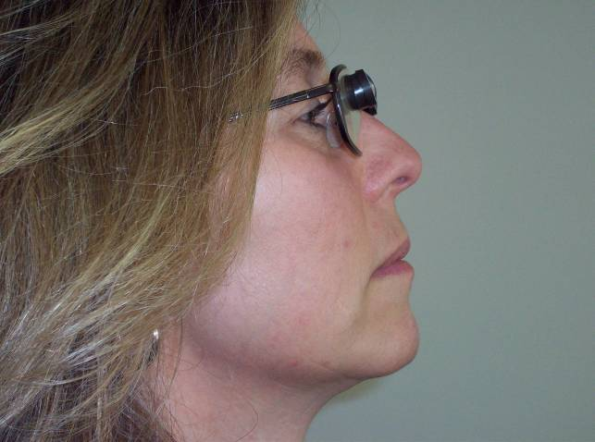
Photo No. 2: A lateral view of a person looking through the carrier lens of a Designs For Vision, Inc. (DVI) 2.2X Galilean BIO II mock-up bioptic telescopic lens system (in new brown titanium frame), Ronkonkoma, NY
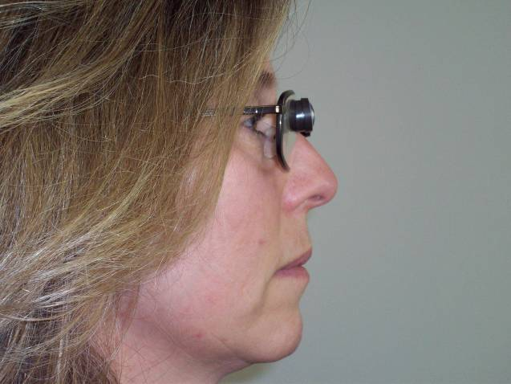
Photo No.3: A lateral view of a person looking through the telescopic unit of a Designs For Vision, Inc. (DVI) 2.2X Galilean BIO II mock-up bioptic telescopic lens system (in new brown titanium frame), Ronkonkoma, NY
During carrier lens viewing, the upper limit of one’s pupil
- Should be parallel or in line with the lower portion of the ocular lens end of the telescopic unit
- The latter offers the best or optimal viewing through the carrier lens and minimal fixation time, going from non-magnified to magnified viewing and back.
Vertical spotting through the telescopic unit of the device is suggested:
- Only on straight or relatively straight stretches of roadway
- Only in the absence of critical objects or forms within the space cushion, surrounding the bioptic user’s vehicle
- Intermittently not continuously
The normal physical location of the telescopic unit of the device:
- Above one’s normal line of sight or viewing
- Will not obstruct the other 95-97 per cent of normal non- magnified viewing accomplished through the larger carrier lens while driving.
The frequency of use of the telescopic unit of the device is:
- Dependent upon the user’s ever-changing driving environment
- His/her familiarity to the driving area
- Dynamics of driving environment
- Individual’s functional vision abilities related to awareness acuity vs. identification acuity vs. sure acuity or preferred viewing distance (with and without telescopic fixations).

Benefits of using this type of optical low vision device?
Once trained in its proper and appropriate use, a low vision driver using a bioptic lens system is able to detect and identify detail, color, and/or movement of critical objects or forms (as described above) at more normal distant viewing positions during the driving task. As a result bioptic drivers increase their margin of safety from such objects or conditions that are present within, along-side of, or approaching their intended path of travel.

Basic bioptic usage skill exercise (vertical spotting)
An easy and effective way to teach a visually impaired person how to properly and appropriately use his/her dispensed bioptic telescopic lens system for visual assistance in the driving task is as follows:

Locate an aisleway within a parking lot approximately 80-100 yards in length:
- Position four (4) parked cars at end of lot or aisleway: two facing in same direction as student(s), the other two cars facing towards student(s). The scenario would mimic a four-lane roadway without a medium between lanes of opposing traffic (see slide below).
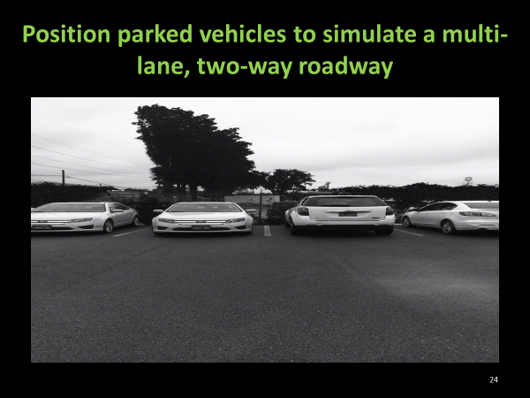

Have student position self:
- Approximately ten (10) yards (30 linear feet) facing the back of the two vehicles facing in the same direction as students.
- If working with more than one student, have students position themselves at arm's length apart from one another, with smaller in stature students in front row, and taller students staggered at same distances behind in second row; so as not to block anyone's field of view of back ends of vehicles.

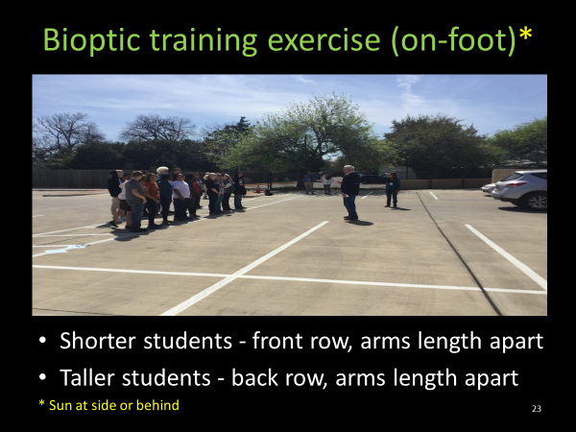

With mock-up bioptics in place on student, instructor will explain and demonstrate how to use the bioptic lens system for driving:
- Simultaneous vertical drop of the head and slight upward movement of the eyes (basic vertical spotting technique)
- Then request that the student reinforce or practice the latter technique five (5) times slowly.

Then have student(s) back up at various ten (10) yard increments, instructor will introduce some of the optical and non-optical characteristics of bioptics; the latter hands-on demonstration and feedback includes exposure and reference to:
- Visual gaze through the carrier lenses
- Difference in image size and linear distance
- Telescopic field(s) of view
- Ring/rectangular scotoma
- Fixation time
- Forward and backward head tilt
- Vertical displacement
- Jack-in-the-box effect
- Apparent movement of objects/forms in opposite direction to head movement while fixating through telescopic unit
- Reference point maintenance through carrier lens(s) and telescopic unit(s)
- Momentary reduction in visual resolution with quick movement/scan of telescopic unit or as a result of vehicle or road vibration/road re-surfacing
- Common distant spotting angles (10-20 degrees from central fixation)
- Awareness vs. identification vs. sure acuities *
- Chromatic aberration
- Weight of the bioptic lens system
- Appearance
- Image quality
- Cost of the device
- Maintenance and insurability

By lesson’s end, students often comment that they have a better idea of how they compare with normally sighted persons in terms of:
- What objects, forms or activity they can detect and identify under magnified vs. unmagnified conditions
- Different linear distances
- Under variable natural lighting and weather conditions.

Students also find themselves capable of using their respective bioptic lens system as an effective vertical spotting device on “stationary viewing activities”:
- After only 1-2 hours training
- Sets the stage for continued bioptic reinforcement under dynamic on-road conditions: first as a passenger-in-car; then while driving.
* Taken from Foundations of Orientation and Mobility, Weiner and Blasch, Eds., 1996 from chapter entitled Low Vision Mobility by Duane K. Geruschat and Audrey J. Smith.

Additional or ancillary bioptic usage skill exercises

Indoors:
- In a large all purpose room or gymnasium, position the student with bioptic in place midway along one of the longer sides of the room or basketball court, facing the opposite side of the room or gym.
- Position facsimiles of common road signs, purchasable through driver education supply companies on the remaining three sides of the room or gym at 7-8 foot height level.
- Have student practice vertically spotting and identifying various road signs, located to the left and right from a centrally positioned sign, on the wall opposite their stationary location.
- As student’s performance improves, have them establish and maintain gross awareness of instructor’s position by pointing with the index finger of their left or right hand as the instructor moves laterally across their bi-lateral field of view while student continues to spot and identify the road signs.

Outdoors (sample passenger-in-car exercises, reinforcing basic vertical spotting abilities):
- Practice squaring off with single lane of traffic or roadway, adjacent lane of traffic, multiple lanes, large size road users, large size guidance signs along secondary highways and interstate roadway systems, etc.
- Practice squaring off with single lane of city traffic, adjacent lane of traffic, multiple lanes of traffic, large and smaller in size road users, road signs, traffic control devices
- Practice approach to stop sign controlled intersections; have student practice vertically spotting stop signs in the following order: near right corner, far left corner (back side of sign), near left corner (if needed) and lastly far right corner (if visible).
- Practice detecting and identifying distant color, detail or activity (i.e. traffic light, speed limit sign, vehicle maneuvers down the roadway).

Hazard Perception Skills
Once novice driver candidate becomes proficient with distance viewing skills, critical object or condition awareness skills, and proper and appropriate use of their dispensed bioptic lens system, it is an appropriate time to introduce and reinforce basic hazard perception skills. The latter include situations where the novice driver candidate learns how to detect when other road users fail to see you, become distracted, execute a driving maneuver incorrectly, or become confused.

Outdoors (sample passenger-in-car hazard perception skill exercises)
- Practice detecting and identifying situations where novice driver’s line of sight to other road users and theirs to them is restricted or hidden (due to fixed hazards such as buildings, utility poles, slope of land, weeds, and crops).
- Practice detecting and identifying situations where other road users become distracted in-car due to cell phone use, eating, personal management practices, talking to other passengers, reading or texting, other road users outside their vehicle, etc.
- Practice detecting and identifying situations where other road users become confused due to: turning the wrong way on a one way street or roadway, turning the wrong way onto an interchange leading off of a controlled access roadway, turning from the wrong lane of one street onto another roadway, etc.
- Practice detecting and identifying situations where other road users execute a driving maneuver incorrectly or unsafely (i.e. related to lane changing, passing, tailgating, blocking an intersection so that cross traffic cannot enter, rolling stops, etc.)

Appendix A

Functional Visual Acuity Terms*

Functional visual acuity assessments use real-world settings with everyday objects such as people, cars, signs and objects that vary in size. To measure functional visual acuity, assess the following:
- Awareness acuity – the furthest possible distance at which the presence of any form is first detected.
Ask the student to look as far away as possible and indicate when the presence of any form is first detected. Examples may include: building shapes contrasted against the sky, blobs or blurs of colors indistinguishable as specific objects, etc.
- Identification acuity – the furthest possible distance at which a detected form is first correctly identified.
Ask the student to slowly move forward and identify the same detected form from the furthest possible distance. As an example, the student may say “that red blob is beginning to look like a car”.
- Sure acuity or preferred viewing distance – the most comfortable distance for identifying a detected form.
Ask the student to move forward until he/she is at a distance comfortable enough to provide sure identification. (e.g., the student states “I am definitely sure now that it is a car”).

* Taken directly from Blasch, B. W. Wiener et al (eds.) (1997). Foundations of Orientation and Mobility, 2nd Edition (pages 74-76), New York, NY: AFB Press.

Appendix B

Functional Visual Field Terms*
Functional visual field assessments use real-world settings with everyday objects such as people, cars, signs and objects that vary in size. To measure functional visual fields, assess the following:
- Static visual field – a measure of the outermost boundaries of the visual field performed in every day environments, with the person in a static position, keeping his or her eyes head and eyes still.
Ex. Tell the student to stand still. Keeping head and eyes still, the student fixates straight ahead on a distant target. The student points to or describes objects seen at the highest, lowest, and farthest boundaries to the left and right.
- Dynamic visual field – a measure of the outermost boundaries of the visual field performed in everyday environments, with the person moving forward while keeping his or her head and eyes still.
Ex. Tell the student to commence moving forward. Keeping his or her head and eyes still while continuing to fixate ahead at distance targets, the student points to or describes objects at the highest, lowest, and farthest boundaries to the left and right.
Remind the student to keep changing targets as he or she moves to ensure that the targets are at least 20 feet away.
- Preferred visual field - a dynamic measure of a person’s regular pattern of viewing in everyday environments, with no limitations on head or eye movement, and emphasis in where visual information is most often obtained.
Ex. Ask the student to walk forward and tell you everything that he or she sees. Tell the student to look around as they normally would. Do not pose limitations on head or eye movements.
Observe the student’s regular pattern of viewing (e.g., frequent scanning, gazes consistently downward, etc.) and where visual information about the environment is obtained (e.g. only notices objects on the right side).
Note, oftentimes a person will respond to what is detected visually via adjustments in walking or vehicle speed and/or lane position before deciphering what the stationary or moving object or form actually is.
The first two functional field measurements, static and dynamic, tell you about the potential area of visual field available to the student. The preferred field assessment, which yields the most significant information, tells you what the student is actually using, given a dynamic situation with no restrictions on how or where looking occurs. This estimates the student’s use of potential field.

* Taken directly from Blasch, B. W. Wiener et al (eds.) (1997). Foundations of Orientation and Mobility, 2nd Edition (pages 74-76), New York, NY: AFB Press.

Texas School for the Blind & Visually Impaired
Outreach Programs
Figure 1 TSBVI logo.

Figure 2 IDEA logo

