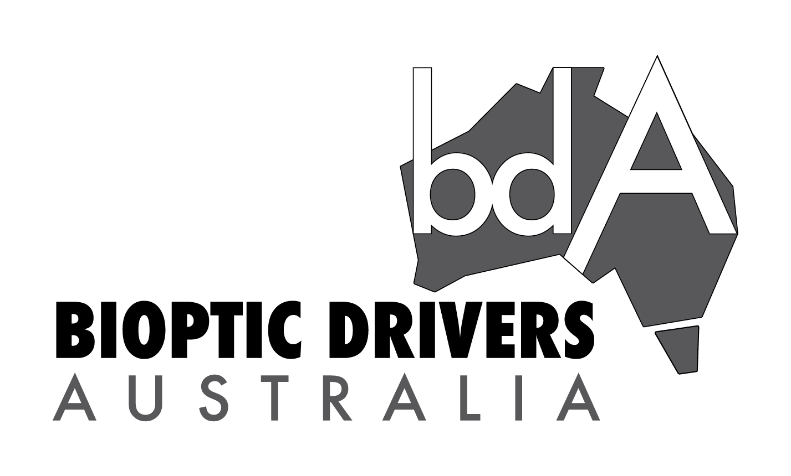

Bioptic Drivers Australia Pty Ltd’s submission to the National Transport Commission’s 2021 review of the national Assessing Fitness to Drive Guidelines

1. Introduction
2. Outcomes sought
3. The bioptic assistive technology and how is it used
3.1 The bioptic and how it is used
3.2 Issues raised about the use of bioptics
4. Setting a vision standard for bioptic drivers
4.1 Historical and international context
4.2 Adding bioptics to the vision standard
5. Disability barriers through the AFTD review process
5.1 Visual acuity
5.2 Contrast sensitivity tests
5.3 Telescopic lenses
5.4 Role of practical driver assessment
5.5 The use of medical panels by DLAs
5.6 Impact of delaying public updates to the legal instrument
6. Road safety
6.1 Disability and road safety
6.2 Use of motor vehicle collision data from the Monash reports
6.3 Use of international motor vehicle collision data
7. Economic factors
BDA contact
Attachment 1 Strategies to facilitate driving in individuals with central vision impairment
Enclosure 1: Introducing an Australian Bioptic Driving Framework

Readers note: this document has been optimised to be read online and for accessibility for people living with disability including blind and vision impaired persons using screen reader software.

1. Introduction
Up to 228,000 Australian’s are being denied civil and human rights to demonstrate they can be safe drivers. This submission is written with the sole purpose of defending the rights of Australian drivers to continue using a life changing technology which is globally accepted and is viewed as normal for many people around the world. This is coupled, in an age of safer road infrastructure, with more advanced motor vehicles with pedestrian and crash avoidance technologies.

Despite the affirmative status of the use of bioptics for driving in Australia, some potential and current bioptic drivers have been told their use is not permitted and subsequently either had their licence conditions modified to remove the bioptic, or their licence denied. Reasons provided for the decisions do not conform to the current legal status of bioptics (nor 40 years of research and practice) and seem to stem from fear and prejudice rather than fact and therefore discriminate based on disability to deny road access to individuals with vision impairment. Bioptic Drivers Australia Pty Ltd (BDA) believes this is happening in Australia due to a lack of education for medical professionals, driving instructors and driver licensing authorities.

BDA seeks to bring the clearly lagging and very basic Australian bioptic and vision guidelines on par with international best practice standards thus providing a globally supported framework for Australian drivers. Many of us reading this report may indeed become bioptic users in the future and safely extend our independence in our later years.

Bioptic driving commenced internationally in the 1940s with the first legal driver licenced in 1971 in California, USA. It is practiced in many countries around the world with formal funded bioptic driving programs in USA, Canada and The Netherlands. In Australia bioptic drivers appeared in the 1980s with the national law Assessing Fitness to Drive (AFTD) Guidelines formally legalising bioptics in 2012.

To support an evidence based agenda for bioptic driving in Australia, BDA had international consulting firm PriceWaterhouseCoopers (PwC), to produce the report at this link and at Enclosure 1:
https://www.biopticdriversaus.com/australian-framework

This report titled ‘Introducing an Australian Bioptic Driving Framework’ finds:

- an estimated 228,000 Australians with central vision loss could potentially benefit from bioptic driving
  - 63k live in smaller cities, rural and remote areas, in which not driving is more impactful
  - 86k are within studying and working age, which could have additional benefits in job seeking and access to higher education
    - Further to the report: Indigenous Austraians have a prevalence of vision impairment 3x to that of the Australian population, targeted programs could be beneficial
- research shows that bioptic drivers’ performance is, at maximum, comparable to the general public and, at minimum, comparable to many groups with higher collision rates that are permitted to drive
- key global case (USA, Canada and Netherlands) learnings are that a uniform bioptic driving framework can increase access to bioptics, ensure consistent assessments and deliver appropriate training to improve safety outcomes.

BDA asks decision makers of public policy to ask themselves if what is put in front of them is based on the best available evidence, if the right experts have been consulted and whether decisions may be influenced by unconscious bias or prejudicial assertions. Ultimately, decisions on assessing fitness to drive are not solely the domain of medical/ scientific specialists; rather, they are decisions of multidisciplinary public policy considerations and political will.

BDA represents people with central vision impairment in Australia who hold a driver's licence or wish to drive using assistive technology of the bioptic. Information about bioptics and our activities as an organisation can be found at our website here: https://www.biopticdriversaus.com/.

BDA is a member of NTIAN (National Inclusive Transport Action Network) which is run through the Australian Federation of Disability Organisations (AFDO) and we collaborate with Disabled Motorists Australia.

2. Outcomes sought

From the Australian and state and territory governments, BDA seeks a formal bioptic driving framework to remove current discrimination. This means:

- A national bioptic driving framework and program approved by ITMM (Infrastructure and Transport Ministers Meetings) through the National Policy Framework for Land Transport Technology and its Action Plan to be overseen by the NTC or Austroads and run through each state and territory; and,
- A standard for bioptic driving medical assessments in the national Assessing Fitness to Drive guidelines to be approved through ITMM.

Ministerial support at all levels of government this year through ITMM for the above would signal to:

- transport departments at both the national and state and territory levels, to implement nationally consistent and non-discriminatory medical and road policy along with pooling project and people resources across jurisdictions;
- Industry, to implement training for eye health, occupational therapy and driving instructor professionals; and,
- the Australian people that, the use of technology and training for potential bioptic drivers (and their use in today’s improved road safety settings of safer cars with driver assist features and better road infrastructure) is a ‘normal’ part of economic participation.

3. The bioptic assistive technology and how it is used

The purpose of this section is to:
- introduce readers to the bioptic assistive technology and how it is used
- discuss issues raised in their use.

3.1 The bioptic and how it is used

The bioptic assistive technology consists of either a miniature Galilean or Keplarian telescope positioned in the upper portion of or on top of a carrier lens.

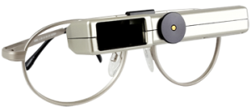 | 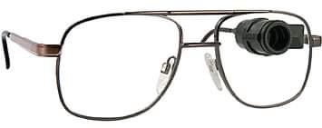
Picture 1 is a Keplarian telescope sitting in a pair of glasses. The scope is positioned in the left lens and connects to a rectangle box sitting at the top of the glasses. The rectangle length is not quite the whole glasses length. There is a window on the left side of the box where light comes in that reflects off the mirrors inside through to the scope and the users eye. | Picture 2 is a Galilean telescope sitting in a pair of glasses. It is a rounded object estimated 2cm in diameter, positioned in the right lens

The bioptic is prescribed by an eye health professional (usually an optometrist or ophthalmologist). The carrier lens, the glasses part of the system, in most cases incorporates the individual’s standard refractive correction. The scope of the bioptic is positioned to be used by the person’s dominant eye and is conventionally mounted in the frame. This arrangement allows the user to look through the carrier lenses for general driving purposes (approximately 90 per cent of the total driving time) and quickly (1-1.5 second per fixation) and intermittently through the bioptic for spotting purposes only, the other 5-10 % of the total driving time. The latter allows the user to detect distant detail, colour (if the eye functions for such) or activity as the dynamics of the driving situation dictates. The below figure also shows the user has two views simultaneously - the carrier lens view and telescope view - a ‘Bi-Optic’ view.

Image shows user looking through carrier lens | Image shows user looking through bioptic | Image shows Bioptic view - two simultaneous views. The view through the bioptic imposed on top of the view through the carrier lens
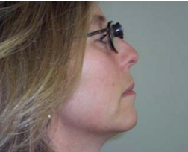 | 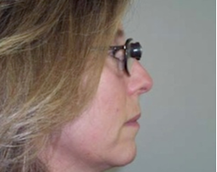 | 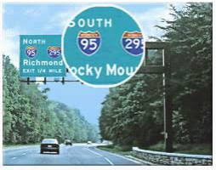

Users require time and training to become proficient in using the bioptic assistive technology. The following is an effective bioptic training sequence that has been used by many individuals.
- rapidly locate stationary objects while still
- rapidly locate moving objects while still
- rapidly locate stationary or moving objects while you are moving (preferably as a passenger in a car)
- develop accurate visual perception skills to evaluate the environment rapidly.

To support the bioptic driver, it is appropriate for jurisdictions to implement a multidisciplinary bioptic driving framework (see below section 3 Setting a vision standard for bioptic drivers). Such a framework is consistent with support already provided to other disabled drivers internationally and in Australia through disability driving programs.

3.2 Issues raised about the use of bioptics
The purpose of this section is to address the common matters raised by those who do not support bioptic driving. It is important these matters are presented and addressed so there can be transparency and discussion. Yet despite countries and states that allow bioptic driving knowing these concerns and arguments, no jurisdiction has ever revoked that driving privilege. This includes states in the USA, Canada and The Netherlands.

BDA has over the last five years received medical reports submitted to a driver licencing authority (DLA) from potential and current Australian bioptic drivers noting many of these concerns to attempt to convince the DLA to deny bioptic driving. These concerns may be raised because medical specialist panel members in DLAs may not understand how the bioptic assistive technology supports the low vision driver. Further, these arguments are not new. For decades such arguments have been put forward in the USA by opponents to the use of bioptics and most use theoretical data under stationary conditions of the use of the bioptic systems, not the dynamic factors, including human ones.

Concern/ misconception | Response
Small visual field through the bioptic telescope | The visual field through various types of bioptics of 6 to 17 degrees is actually larger than the 5 degree foveal (precise vision) area for a normally sighted person with 20/20 vision.
Ring scotoma causing a hazardous blind spot | The ring or rectangular shaped scotoma (blind area) around the telescope does not pose a hazard when the bioptic user moves their head and is moving through space in a vehicle because no object can be “lost” for a significant length of time in the scotoma under these conditions.
Vibration and speed blur | Everyone, no matter what vision they have, experiences deterioration of the visual image due to speed blur at increased speeds and this phenomena is unrelated to the use of the bioptic.
Telescopic parallax (shifting of view) and depth perception | It is unnecessary to have binocular vision in order to perceive depth. Drivers who have vision in only one eye (but do not have low vision) perceive depth monocularly and drive safely.
Critical adjustment of the bioptic frame and angle of the lens. | A bioptic focused for distance will be able to magnify the reflected image for the user as if the user were looking at the object in the distance. Adjustments of the lens and frame are critical. Most prescription bioptic lens systems present adjustable nose pads and spring loaded hinges for a snug fit. Follow-up with the dispensing clinician assures that the latter system is positioned correctly.
Users do not look through the bioptic all the time and therefore do not meet the vision requirements. | The purpose of the bioptic assistive technology is to allow the user to use the system and training to compensate for central vision loss to drive safely.  The intermittent use is appropriate to meet this goal. Over 40 years of practice and research demonstrates the effectiveness of this assistive technology.  Where the driving standard does not state how a bioptic is used, practice shows the minimum acuity figures for an unconditional licence is also used for the acuity through the scope. In most countries this is 6/12 (20/40).
At present there is little information on the safety or otherwise of drivers using these devices. | See discussion throughout this paper
Biopticuse may reduce visual perception in the periphery. | This is based on the mistaken view that the user looks through the bioptic 100% of the time.

4. Setting a vision standard for bioptic drivers
The purpose of this section is to:
- discuss how vision standards have been set historically and compare vision standards internationally. This will show how other jurisdictions provide for evidence based standards and decisions to allow vision impaired people who demonstrate merit, to drive
- put forward what experts say about a vision standard for low vision drivers with the option of a bioptic
- give example for the Australian context on a vision standard for bioptic drivers.

4.1 Historical and international context
World wide the commonly used threshold for an unrestricted (Australian term ‘unconditional’) drivers licence is 20/40 (equivalent to 6/12 or 0.5) is accepted.

The International Council of Ophthalmology ICO in its 2005 report “Vision Requirements for Driving Safety” provides a set of considerations for refinement of driving licence requirements. The report addresses individual assessment of visual functions and their relation to functional vision in the context of vision requirements for driving safety. The ICO in their 2002 report distinguished several aspects of vision loss notably visual functions, which describe how the eye functions and functional vision, which describes how the person functions in vision related activities. The ICO states this relationship is complex and individual performance can be considerably better or worse than the general population. This is one aspect as to why to recommend a case by case assessment of people with acuity of less than the above accepted 20/40 to allow for restricted (conditional) driver licences. In their 2005 report the ICO says:

“Traditional clinical tests determine a performance threshold. Real-life performance requires sustainable, supra-threshold performance. Establishing driving license criteria therefore is an exercise in establishing a safety margin between performance on clinical tests and performance in actual traffic, rather than a cut-off value between competence and incompetence.

A literature review shows that there is a relationship between the safety margin established by vision-related driving license requirements and actual driving performance, but that this relationship is generally weak.”

Ultimately, driving safety does not depend so much on what is seen, but rather on how quickly and how adequately drivers respond to what is seen. Finally one must also stress that Driving is a privilege not a right and that the primary responsibility of those who assess potential drivers is to the public not to the applicant.” (ICO:2005)

The ICO recommends that countries worldwide adopt 0.5 visual acuity and 120º horizontal visual field as a screening point for an unrestricted licence. The report recommends such requirements “not because one becomes unsafe at 0.4 but it includes a safety margin for adverse conditions.” They note anyone who has 0.5 (6/12 or 20/40) visual acuity is likely to retain enough vision to drive safely in the dark, rain, fog or other poor conditions. They further recommend that case by case assessment to those in the 0.5-0.1 range (6/12 to 6/60), with additional vision, cognitive, and functional tests, including a road test, if there is any doubt. The regime for a vision standard should look like this:

20/40 (0.5 or 6/12) or better | No visual acuity-based objection to an unrestricted driving license, even if acuity could be further improved with glasses or contact lenses.
< 20/40 (< 0.5 or 6/12) to 20/200 (0.1 or 6/60) | Individual consideration, which may result in restrictions or denial. Evaluation should include visual and non-visual factors and a road test when in doubt. Some licenses may be granted, some will not.
< 20/200 (< 0.1) | No driving license

In his 2005 article, Howard Larkin discusses the considerations about minimum level of vision for driving: Article: “When should a visually impaired patient stop driving? With clinical measures uncertain, driving tests may be the best way to tell”

“Because driving is so dependent on vision, common sense dictates that driving must be unsafe beyond a certain threshold of visual impairment. This idea is so compelling that traffic authorities worldwide restrict or prohibit driving by persons with defects in visual acuity and often in visual field. Problem is, the scientific evidence linking these clinical measures of vision to unsafe driving performance is weak to non-existent, says Eli Peli, OD, professor of ophthalmology at Harvard Medical School in Boston, US. The correlation with visual acuity is especially tenuous…Dr Peli says.

“Legislators look at the state next door and they adopt similar standards because that is what people are used to and what they will accept.” The result is a wide variation in the vision requirements for driver licensing….

In Dr Peli’s view, these standards are not just intellectually questionable – they are potentially discriminatory. Drivers with other common medical conditions, including impaired hearing, coronary disease, and movement disorders, present a similar risk, as do drivers generally over the age of 70 years. Those drivers, however, are not singled out for restriction, Dr Peli points out. Prohibiting low-vision drivers who have demonstrated proficiency in road tests would have a negligible impact on overall accident rates at the cost of restricting the mobility of many, mostly older, citizens, Dr Peli says.

Further, “if public safety is the issue, the evidence is overwhelming that the biggest problem is at the lower end of the age spectrum. Youth, gender, and years of driving experience are far better predictors of poor driving performance than low vision. “The worst offenders are young men. Their accident rate is as high as 20 times that of the general population, yet no one suggests they should be denied licences,” notes Dr Peli...”

Dr Peli emphasises.“ At the moment, we cannot tell by vision tests alone who should or shouldn’t be on the road. The only reliable test is to take them on the road and see if they can drive safely…”

“{In the USA}…all states require applicants for an unrestricted personal driver’s license to meet one (or more) vision standards, the most prevalent being that an individual have a visual acuity of 20/40 or better. The general public is likely to believe that such standards can separate safe drivers from unsafe drivers… no hard scientific evidence justifies existing vision standards for driver licensure… there certainly is no sufficient evidence supporting the belief that a particular level of visual acuity clearly distinguishes safe from unsafe drivers… numerical values representing vision-test results should not be the sole basis for granting or denying the driving privilege. People with vision loss who have appropriate low-vision aids and training frequently show a remarkable ability to compensate for their diminished visual abilities.” (Peli:2002)

Types of testing that can be included in a vision standard

As discussed above, a person’s fitness to drive cannot be determined alone by their vision acuity, vision field, vision function or functional vision or age etc. “The functional manifestations of various ocular conditions and an individual’s ability to compensate for any visual impairment varies widely. We [optometrists] must use our knowledge and tools to assess competency to drive or refer to a driver rehabilitation specialist for additional assessment.”

In its 2005 report, the ICO discusses tests that could be used. They state “In the context of driving safety, however, we are interested in tests of functional vision that explore not the causes, but the consequences of vision loss… There is a need for screening tests that do not require highly trained personnel and that assess functional vision, based on a wider array of visual functions than visual acuity alone. We encourage the development of tests that may assess a combination of parameters… It should be stressed again that these tests (like any of the other tests discussed) are screening tests, not tests of driving competence… The licensing office may require an on-the-road test (the only test that assesses actual driving competence) and will make the ultimate decision.”

Testing described includes:
- proposed screening test for contrast sensitivity
- proposal for a combined test for visual field, scanning strategy and reaction time
- proposal for a combined screening test for attention, contrast and night vision.
Details can be seen in the ICOs 2005 report.

Conditional / Restricted licences

The ICO states “...driving license requirements are meant to establish a safety margin between performance on a stationary letter chart in the office and performance in actual traffic situations under adverse conditions. For professional drivers the safety margin can be improved by imposing stricter requirements. For general drivers the safety margin can also be improved by prohibiting driving under certain adverse conditions. This is the purpose of issuing restricted licenses.”

In Australia, a simple and common example of a conditional licence is where a person must wear glasses and/or contact lenses to meet the 6/12 threshold. The person is given an eyesight report to provide to their DLA who then makes a decision whether to issue a driver's licence ‘conditional’ on the person wearing their glasses while driving.

For people with vision less than 6/12 the vision specialist can advise the DLA on possible license restrictions and on the reassessment interval. The DLA will consider this advice and possible additional information, such as other medical problems and past driving performance and must have available to them the option to require an on-the-road test. The ultimate responsibility for issuing or not issuing a driving license, with or without restrictions, is decided by the DLA, not with the ophthalmologist/ optometrist or other organ specialist and not solely on such a report from a specialist.

Various restrictions could be imposed including:
- must wear glasses
- must wear bioptic
- limitation to daylight driving
- restriction to a radius of …. km from home
- restriction to familiar areas
- speed limitation
- no highway driving
- requirement of more frequent testing, based on the prognosis of the condition.

The DLA in considering the above and having the option to request an on road driving test can give opportunity for people with vision impairment to train to improve performance. Such allows the person to learn low vision driving skills in the task and is only done if the eye specialist recommends to the DLA the person could be issued with a conditional licence.

As an example of using training help vision impaired person’s, in its 2005 report, the ICO notes:

“Coeckelbergh (2002) [28] has shown that some patients with retinal scotomata can benefit from training. About half qualified for a driving license after 12 training sessions. Tant (2002) [29] has shown that training can also improve the performance of patients with homonymous hemianopia, although these patients did not reach the criteria for a driving license. Studies are under way to test the use of prisms in patients with hemianopia.
Again, training may help in some, but only an on-the-road driving assessment will determine whether an individual patient can be allowed to drive.”

Research conducted in 2016 for Australian optometrists showed they are receptive to learning of options for assessing people with central vision loss (vision impairment) and management strategy varies amongst specialists.

Country review

As discussed above, vision standards vary internationally and not due to absolute scientific evidence but rather, public policy decisions underpinned by evidence and information put forward at that time by interested stakeholders. Examples include the unique requirement for the United Kingdom that requires a person to read a number plate at 25 yards where people with acuity of 6/12 can fail such a test (ICO:2005). And in Iowa allowing people to drive with acuity to 20/200 (legally blind and without the use of bioptics) where clinical experience has shown many have continued to drive safely for decades.

It is important to understand that once allowed, no jurisdiction worldwide has ceased bioptic driving. Bioptic driving programs continue to be expanded and licensing conditions continue to be relaxed for both the programs and on a case by case assessment where appropriate for an individual.

Decades of research and practice means Australian authorities have a plethora of information to draw on to develop a bioptic driving program for the Australian environment.

The Netherlands

Bioptic driving in The Netherlands was contemplated first by a research study followed by advocacy to the government. CBR (Dutch driver licensing organisation) worked closely with the Royal Visio, the Dutch institute for the blind and visually impaired. They developed training for all parties involved including occupational therapists, optometrists, driving instructors, experts on practical fitness to drive. The Royal Visio is the only institution that may issue a certificate that the driver with a bioptic has had sufficient training to make them safe to do the on road test with the experts of CBR. In 2018, there were 150 bioptic driving program participants.

Since 1 November 2019 bioptic drivers in The Netherlands are allowed to drive at night after holding their licence for one year. This change was supported by a study with University of Groningen on driving by night with a bioptic. This change was implemented through the Dutch Legal Criteria for Fitness to Drive so that persons with a bioptic device are no longer restricted to driving by daylight, after they pass an on road driving test at night.

The Netherlands also originally excluded individuals with nystagmus, and then after a study permitted them to enter the driving program.

Canada

BDAs correspondence with the experts and specialists involved in managing the bioptic driving program in Canada have advised information in the 2017 presentation at this link is still current:
https://www.caot.ca/document/5902/T3%20Bioptic%20driving%20program%20multidisciplinary%20rehab%20allowing%20low%20vision%20patients%20to%20drive%20safely.pdf

The program began around 2009 with a consortia of multidisciplinary stakeholders coming together to make it happen. The rehabilitation center that runs the bioptic driving program selects 12 patients each year to participate in the training program. It is funded by the provincial government and there is currently a waiting list of about 3 years. Successful participants get a day-driving only licence. They have advised that 100% of students that have completed the program have received their driving licences, but not all who begin finish naturally for a variety of reasons. They have advised their program was influenced by similar initiatives in the United States.

The Quebec Automobile Insurance Society (their regulatory board) have conducted some studies to monitor the performance of their bioptic drivers since the beginning of the program. Also, some of their drivers have participated in a study that was recently published by a team from Boston, USA and there is further research being conducted.

United States of America (USA)

In the USA, each state sets its own vision standard. Historically, the 20/40 (equivalent to 6/12 or 0.5) is based on an American Medical Association recommendation dating back to 1937. The first bioptic driver was legally registered in California in 1971. The number of states that allow the use of bioptics for licencing continues to increase overtime as the matter is reconsidered from time to time. Specialists and people with low vision have reported that inconsistent vision standards across the USA has a significant impact on economic decisions for potential bioptic drivers such as where to attend university, where to work, where to raise a family. The ICO report referenced throughout this submission provides a summary from 2005 and another source can be seen here:
http://www.biopticdrivingusa.com/state-laws

The formal bioptic driving programs in Canada followed by The Netherlands have been put in place through cooperative means. In the USA, the wide variation of requirements and as the trail blazers in this endeavour, has seen the evolution of civil and human rights driven by court case rulings. Such rulings found that automatically denying licensure of people living with vision impairment was disability discrimination and that individuals on a case by case basis must be allowed to demonstrate that they could or could not pass a driving test. This led for example, Indiana and many other states, to develop careful standards for the process of eligibility, training and licensure.

The rehabilitation system in the USA, similar to operation in Australia, in each state allows for funded places for disabled people to improve employability. The cost of the bioptic system itself, as well as the necessary training, is funded for the clients, as a vital tool to improve employability. It is a prosthetic device, even if not used for driving, as it improves accessibility for the individual to read signs, view presentations in classes or seminars, etc. This is similar to providing a power scooter for those who cannot walk well, or modifications to a vehicle so an amputee can drive. Disabled people can also pay privately for devices, the training and rehabilitation as the legal systems facilitate such.

As has occurred in the USA, here in Australia, overtime economic opportunities for all players improve as institutional systems mature to support low vision and bioptic driving. This will mean industry training for eye health professionals and driver trainers as they become knowledgeable and comfortant with bioptics. BDA believes such supports Australia’s aging population allowing more people to continue to be economic participants contributing to Australia’s prosperity.

4.2 Adding bioptics to the vision standard
As noted in the above discussion, the action of adding bioptics to a vision standard can be achieved through making it one of the options available under the conditional driver licence framework.

The option is available to individuals assessed by an eye health professional as a ‘candidate for bioptic driving’ as part of the multidisciplinary system. An example of a bioptic driving framework is provided at Attachment 1 ‘Strategies to facilitate driving in individuals with central vision impairment by Dr Sharon Oberstein who is an Australian clinical and research expert in bioptics.

BDA supports the ongoing use of the 6/12 for an unconditional drivers licence yet notes there is evidence, research and practice internationally that could be used to support updates to the vision standard on how conditional licences can be applied. Such approach is also in line with Monash University Accident Research Centre report noting the importance of using conditional licences over strict cut offs:

“A number of authors have argued that decisions about licence status need to be individually determined and indeed for many conditions (particularly where cognitive decline is implicated), specify that licensing privileges should be issued on a case-by- case basis, as distinguished from blanket restrictions for a given medical condition. Conditional licences may be particularly relevant for those who live in areas poorly serviced by public transport. Arguably, the decision-making process should incorporate a range of relevant issues including individual nature of the condition (co-morbidity; level of severity) as well as individual drivers’ capacity for rehabilitation, as well as their lifestyle and mobility needs (proximity to services; access to alternative transport, etc).”

In managing the safety of road users, licensing agencies face difficult decisions about personal and public safety. On the one hand they are obliged to produce regulations and guidelines that provide optimal protection of the community. Yet, at the same time they must ensure that such regulations are not overtly restrictive on the rights and opportunities of the population, particularly in regard to the capacity of individuals to earn a living (Helbach, 1991).

Whilst the purpose of the standard is to protect public safety, they should not be used as a barrier to employment. The system of conditional licenses aims to support employability without compromising road safety (including period reviews and conditions on the licence).

Adding further information in the AFTD guidelines about conditional drivers license recommendations with cooperation with health professionals for joint reports, particularly for rehabilitation and habilitation is consistent with the principles of assessing fitness to drive. “…the driver’s functional abilities in relation to driving including their capacity to compensate and the need for rehabilitation.”

However it seems time constraints of the review of this standard may not allow for appropriate examination of this matter. BDA further notes that previous reviews of the AFTD guidelines have too referred to limited sources of evidence, research and practice to decide on the vision standard. This lack of consideration unfairly disadvantages people with vision conditions who otherwise could demonstrate they could be safe drivers. BDA calls on organisations to come together to support development of a vision standard that reflects more considered input and that such is done before the next review of the AFTD.

The current AFTD guidelines and vision standard should be updated to include detail on a multidisciplinary bioptic driving framework. The recommendation for a bioptic conditional licence should only be made following:

Step 1 - Eye health professional evaluation

Evaluation: an assessment by an eye health professional determines in their view the client is a ‘suitable candidate’. The eye health professional undertakes the bioptic device fitting and filters (glare or colour tints) where needed. The person is shown how to use the bioptic for the driving task and compensatory skills training.

A typical example is what is used in Canada where the vision ‘suitable candidate’ outcome criteria is:
- Mono VA < 6/60 in the better eye and binocularity (through the carrier lens)
- Visual acuity through the bioptic scope of 6/12 or better
- peripheral field of at least 120 degrees
- Contrast discrimination (road signage) (and may be following consideration of colour filters/glasses to be confirmed in next stage)
- Colour discrimination (brake, blinker and traffic lights) (and may be following consideration of colour filters/glasses to be confirmed in next stage)
- Glare compensation including driving behaviour skills (and may be following consideration of colour filters/glasses to be confirmed in next stage)

A report is written on recommendations (or not) considering all above factors and provided to the DLA and the client’s chosen driving instructor.

Step 2 - Habilitation (new drivers) / Rehabilitation (previous/current drivers):

Training and assessment by a disability driving instructor or occupational therapy driving instructor or any driving instructor working in collaboration with an Orientation and Mobility specialist for a three month commentary driving program and practical driving assessments. This is to allow people with a disability to be able to demonstrate they have developed the ‘compensatory skills’ to drive safely. Thus, allowing the person to carry out the following tasks to a greater distance:
- see the details
- recognise and detect signs and various risks
- improve the reaction time.

In considering the eye health professionals report of the suitable candidate, factors for accommodation, training and assessment by disability driving instructor, occupational therapy driving instructor or driving instructor supported by an orientation and mobility specialist can include:
- Distance detection (pedestrians, cars, signage)
- Contrast discrimination (road signage) (and may be following consideration of colour filters/glasses)
- Colour discrimination (brake, blinker and traffic lights) (and may be following consideration of colour filters/glasses)
- Glare compensation including driving behaviour skills (and may be following consideration of colour filters/glasses)
- Basic orientation abilities and mobility habits.

Each professional in the framework reinforces bioptic training and compensatory skills and assists with further skills where required through to commentary driving leading to on-road practical training and assessment in a dual brake car. The purpose of this stage is to integrate the learning.

In addition to this training, it is an opportunity for the client to sit as a passenger in any car with a licensed driver to practice what they are being taught by these professionals.

This process can also involve referral back to the eye health professional on recommended changes to conditions and adaptations learned through the habilitation / rehabilitation process and after the client has had time to embed adjustments and learnings. Examples can include changes to the shading/tint colour of the lens, adding a heads up display or half moon blind spot mirrors.

Step 3 - DLA

At this stage, a ‘multidisciplinary’ report form the above professionals to be provided to the driving licencing authority (DLA). In consultation, the above professionals can agree to recommend to the DLA a conditional drivers licence that includes conditions relevant to the outcome of the above. Conditions recommendation can be one or more of the following but not limited to:
- to use bioptic glasses system at all times
- use of filters for day time driving
- no night driving in the first year
- km restrictions.

If the report recommends the conditional licence, the person can then commence the usual state or territory licence process with ongoing support where deemed, from the driving instructor of the bioptic driving program.

Periodic Review:

Medical reassessment per usual AFTD guidelines and state and territory processes for all persons. This is also following the DLA’s consideration of the eye health professional’s recommendation of reassessment. This is more pertinent for clients with deteriorating eyesight conditions. Medical reassessment can allow for changes in recommended conditions on the licence including to remove or add: night driving, distance from residence and/or certain routes or other conditions appropriate to the person and their driving task.

An annual or regular assessment beyond the standard for all is not needed for persons with congenital and non-progressive eye conditions. The 2012 AFTD guidelines at section ‘4.5 Congenital Conditions’ notes persons born with a condition or from childhood “...may have developed coping strategies that enable safe driving despite their impairment.” The section notes the need of assessment by a specialist and possible tutoring prior to a practical assessment. That a conditional licence may be needed to identify specific vehicle modifications and if the condition is static, period review may not be required.

Co-design for the potential bioptic driver

Unfortunately, due to lack of information and misinformation, many people who are potentially eligible to be assessed to determine if they are a candidate for bioptic driving do not know it exists or have been told it is illegal in Australia. Further, there are long standing bioptic drivers who live in fear of having their driving privilege taken away from them. Not because they have done anything wrong, but because of who they are, people living with vision impairment - this is not okay. Potential and current bioptic drivers need and deserve each certainty in legal settings and the market place.

BDA has sought to correct misinformation and has established communities around low vision and bioptic driving including a website and social media presence to include publicly available discussion groups and private discussion groups for practitioners and bioptic drivers. BDA’s comprehensive website was developed with the help of consumer behaviour students from the University of Wollongong with video examples of bioptics, international links, case studies and published research papers serving as an excellent information portal.

BDA’s discussion groups have been important in helping stakeholders learn how practice is done internationally both for practitioners and for potential drivers. Sharing of stories helps create possibilities. People can look at others and consider if what they have done is possible for them and seek out further information to make decisions. As an example, people living with no colour vision, are extremely glare sensitive and have central vision loss may benefit from adaption to their bioptic and to their car. Other people with central vision loss may also benefit from some of these adaptions. Such information sharing allows the potential drivers and the practitioners to work together in finding solutions to help them feel more comfortable with overcoming disability barriers for driving. It also provides lifelong learning and self-efficacy for the potential bioptic driver. Critically however, this community allows drivers to talk about road safety strategies. Some of these include:

- to plan their route using google satellite maps and use a voice activated GPS to listen to directions but not look at the map
- make use of a fully sighted passenger if travelling in a new area or want to ‘scout out’ a new location
- be aware of sunrise and sunset impacts on driving routes throughout changes in seasons if you are glare sensitive and look for alternative driving routes at critical times of the day or plan to leave a little earlier or later to avoid the issue
- always have a clean windshield and keep vinegar in water in a bottle to clean if needed
- periodically practice the low vision driving techniques learned such as ‘bouncing the eyes’ to scan in the distance and pull to the front and back to keep your brain processing what is in front of you and ahead and helps keep lane positioning.

Some of the adaptations used by low vision drivers include:

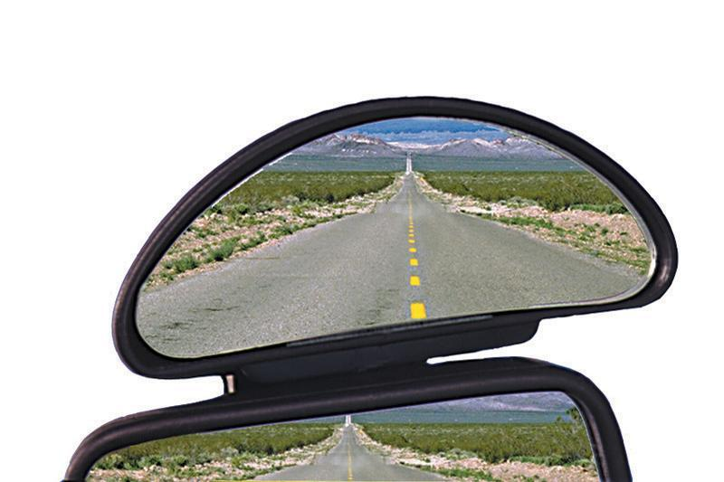 | Hercules Auxiliary blind spot mirror  This picture shows a half moon shaped mirror that attaches to the side mirrors of a passenger vehicle. The mirror expands the viewing of the car’s blind spots.
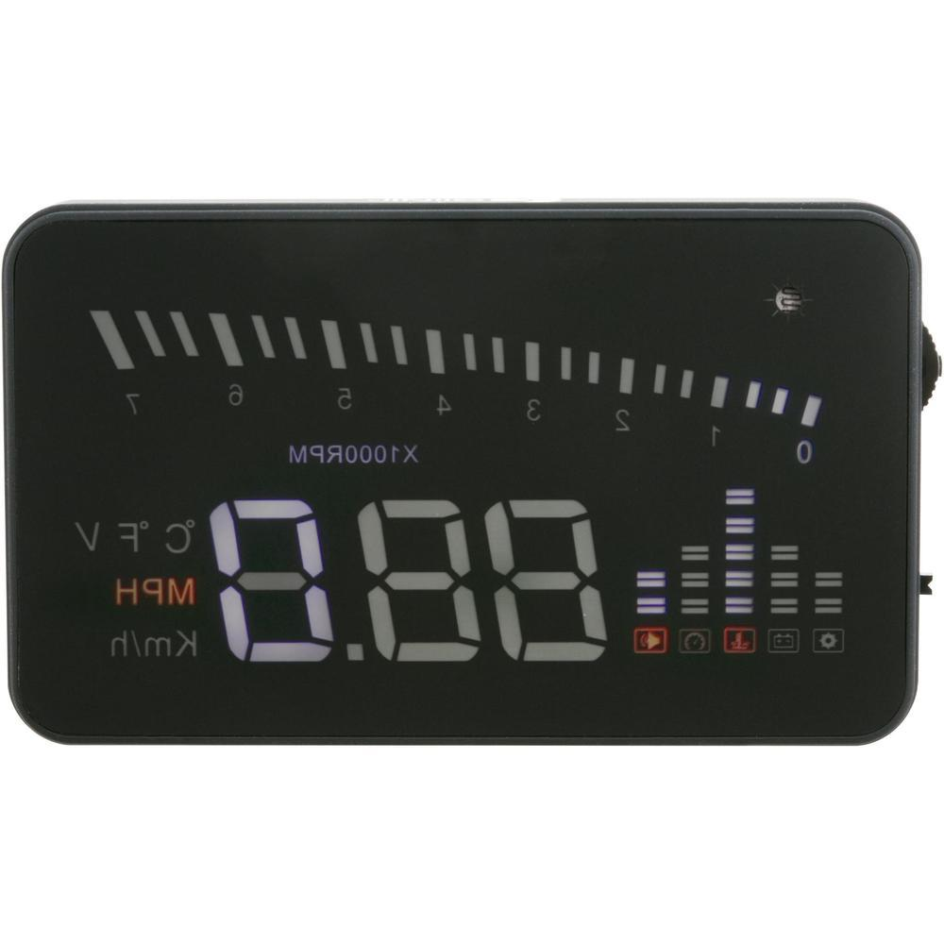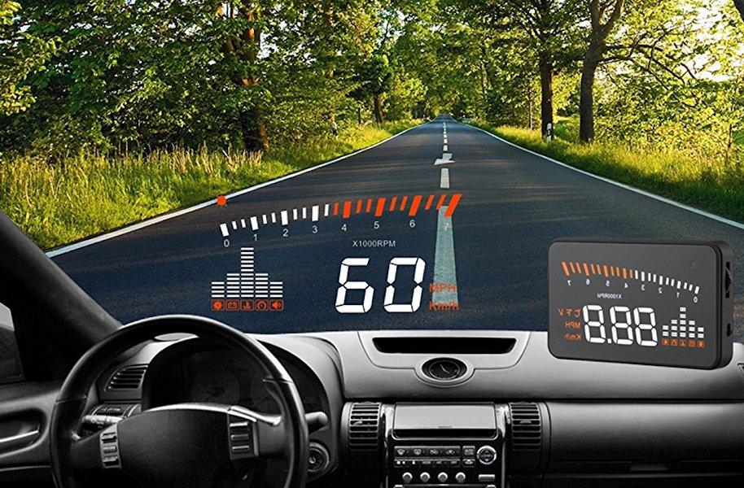 | This picture shows operation of a heads up display plugged into the OBDI port and used to read speed more easily for some with low vision who have difficulty reading the car’s inbuilt speedometer.  There is a small black box secured to the driver's side dash. There is a foil square adhesive patch on the windscreen. The light from the box projects the image onto the foil to give contrast against the window to see the speed number.
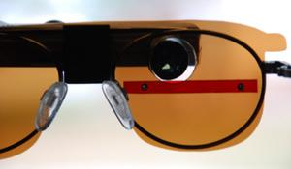 | Colour filters are used by people with varying colour deficiency conditions to improve their functional vision.  The picture shows a colour filter that has been slipped behind the glasses.

5. Disability barriers through the AFTD review process
The purpose of this section is to discuss the disability barriers identified through the AFTD review process and put forward evidence based ways to implement public policy in these matters. This section will discuss:
- visual acuity
- contrast sensitivity
- telescope lenses
- the role of practical driver assessments
- the use of medical panels by DLAs
- impact of delaying public updates to legal instruments.

5.1 Visual acuity
Setting a vision ‘cut off’ is a policy decision, not a medical one. Although VA has been widely used in driving regulations for decades, it is a poor predictor of performance. The correlation of VA alone to accidents is less than 1%.

The NTC’s interim review report noted under VA “Findings from Influence of chronic illness on crash involvement of motor vehicle drivers: 3rd edition reiterated the challenges in defining minimum vision standards for road safety. The report found that the available evidence doesn’t indicate that current standards should change, noting that the finding is limited because few drivers with a visual acuity less than 6/12 are included in the examined studies, preventing the evaluation of an alternate cut-off point.”

BDA notes that in addition to this one Monash report the NTC considers international resources more broadly that demonstrate practice for setting standards for vision acuity. As has been pointed out above through references to the ICO 2005 report and practice in countries that permit restricted/ conditional licences to persons with acuity less than 6/12.

BDA further notes, there is over 40 years of practice here in Australia of people who use bioptics. As the bioptic is prescribed using the 6/12 cut off through the scope, Australian bioptic driver’s acuity through the carrier lens ranges from 6/12 to 6/60. BDA understands however that DLAs do not currently have a mechanism to capture the condition code that identifies bioptic drivers over drivers with other medical conditions in the ‘x’ category. BDA welcomes the introduction of a bioptic driving framework and more consideration of functional vision assessments for person’s with acuity less than 6/12 but better than 6/60.

BDA also understands there is yet to be research done in Australia for bioptic drivers. BDA welcomes such research.

BDA has received reports from some bioptic driving licence applicants that DLA misinterpretation of the AFTD guidelines of 6/24 through the scope has led to refusal of application. Even where the person has been assessed by an expert in the use of bioptics and determined to be a candidate. BDA requests clarity is added to the table as noted below. As noted above, many of BDA’s current members have been driving for years and have been assessed using the standard measurement of 6/12 through the scope and where the vision through their carrier lens falls below 6/24 in some cases well below. It would therefore be questionable if the standard were to be updated to only allow 6/24 through the carrier lens. This would create a need for current bioptic drivers to contest refusals of a driver's licence through the courts.

As an interim option to improve clarity, BDA recommends the following updates to the wording in the table as in bold:

Visual acuity
A person is not fit to hold an unconditional licence:
• if the person’s uncorrected visual acuity in the better eye or with both eyes together is worse than 6/12.
A conditional licence may be considered by the driver licensing authority subject to periodic review if the standard is met with corrective lenses or orthokeratology therapy or a bioptic telescope.
Some discretion is allowed in application of the standard by the treating optometrist, or ophthalmologist. However, a driver licence will not be issued when visual acuity in the better eye is worse than 6/24. For the bioptic telescope, if the visual acuity through the scope is less than 6/12 and through the carrier lens less than 6/60.

5.2 Contrast sensitivity tests
The NTC’’s interim report on AFTD guidelines notes:

“A submission questioned whether it was appropriate to specify standards for contrast sensitivity. Medical specialist advice noted that there is no accepted standard test or cut- offs for contrast sensitivity and that evidence linking reduced contrast sensitivity to driving ability is situational and limited. The available evidence suggests contrast sensitivity would be an ineffective pre-screening tool to identify drivers who pose a road safety risk. Including a contrast sensitivity standard as part of routine vision testing was not supported. It was noted that contrast sensitivity testing may provide further information for borderline cases and when considering conditional licences, which is already provided for in the current guidance. No changes have been made.”

BDA notes per the above discussion and as advocated by the ICO, contrast sensitivity is significant but rarely tested when considering conditional licences. Per the above discussion on conditional licences, BDA recommends the NTC consider what is put forward by the ICO on how to use a contrast sensitivity test as one of the tools in assessing functional vision.

5.3 Telescopic lenses
The NTC’’s interim report on AFTD guidelines notes:

A number of submissions requested vision standards and licensing criteria for the use of bioptic devices and guidance for medical professionals to assist in training and use of these devices. Medical specialist advice did not support the proposed standards or criteria for conditional licensing. A consensus position supporting the use of bioptic devices could not be reached among the expert advice provided, which included recommendations to prohibit the use of bioptics to meet the visual acuity standards. Areas of consensus among medical and health professional stakeholders will be required before considering further changes to this section. It was noted that there is inconsistent approval across international fitness-to-drive standards for using these devices when driving and/or to meet visual acuity criteria. Edits were provided to the current section to update accuracy. No other changes were made to this section.

As BDA has discussed with the NTC and other parties, the decision to add bioptics is not a scientific one but a public policy decision. As BDA has discussed above, we believe that decision hinges on factors beyond fitness to drive, noting of course that over 40 years of practice has shown that bioptic drivers can be safe drivers. Further, no jurisdiction that has introduced bioptic driving has revoked the driving privilege. Above discussion sets out a proposed bioptic driving framework for Australia.

BDA recommends updating section 10.2.7 to include reference to the above testing suggested by the ICO to provide further guidance to eye health professionals on how to conduct an assessment for a conditional licence. This includes assessments such as:
- screening test for contrast sensitivity
- a combined test for visual field, scanning strategy and reaction time
- for a combined screening test for attention, contrast and night vision.

In the absence of a formal bioptic driving framework currently in place, the addition of referencing the use of these screening tests will given eye health professionals and DLAs tools to consider and more confidence in the process to consider bioptic drivers.

In addition to the above screening tools, BDA recommends this section is also updated to include information about the types of conditions that can be added to a potential bioptic drivers licence and how those conditions are derived from the eye health professional considering the testing noted above. These updates will help the DLA form a view on consideration of a holistic view of the person.

5.4 Role of practical driver assessment
The NTC’’s interim report on AFTD guidelines notes:

During the 2012 and 2016 reviews, submissions were received regarding the need to allow for practical driving assessments for people with low vision or who failed meeting the standards but would potentially be able to safely drive with a conditional licence. During those reviews, the advising experts considered on-road assessments to be inappropriate because they are unsafe and not effective in assessing ability to see emergency situations. It was not considered appropriate to grant a conditional licence based on evidence of safe driving practice (no accidents). The advisory committees at the time determined that the proper application of the standards was sufficient and that practical tests would not be recognised.

A number of submissions to the current review requested that this matter be reviewed again to permit practical driving assessments for people with low vision or who are borderline for meeting the standards. A consensus position among medical experts could not be established on the suitability of a practical driver test to identify if someone with low vision could drive safely in a range of road conditions or react appropriately in emergency situations. Areas of consensus among medical and health professional stakeholders will be required before changes can be considered. No changes have been made to this section.

BDA considers that the above framing of the matter of the role of practical driver assessments needs clarification both in the standard and amongst stakeholders.

The above seems to suggest people with low vision would use a practical driving assessment ‘in lieu’ of eye sight testing for the conditional driver licence. BDA believes that such is not the intended interpretation of the standard nor what happens in practice in Australia and internationally. BDA also considers that such a misunderstanding may also have led to prejudicial assumptions about people with vision impairment.

BDA notes the following statements are unfounded as there is insufficient supporting evidence to prove such statements are true (note the below discussion on road safety matters and above discussion on what the ICO considers on these matters including a holistic consideration):

- the advising experts considered on-road assessments to be inappropriate because they are unsafe
- and not effective in assessing ability to see emergency situations
- suitability of a practical driver test to identify if someone with low vision could drive safely in a range of road conditions or react appropriately in emergency situations
- It was not considered appropriate to grant a conditional licence based on evidence of safe driving practice (no accidents).

BDA has put forward with evidence included in this submission that practical driving assessments, along with a person’s driving history are included as a holistic consideration by the DLA in making the decision on whether to grant a conditional license. In such a holistic process the DLA will consider all other relevant factors for each person on a case by case basis such as comorbidity. As an example, when considering older persons (over 50 years) “other medical and functional co-morbidities common in late adulthood are potential confounders in understanding the relationship between vision and driving. In particular, cognitive impairment elevates crash risk and impairs driving performance”.

This, of course, is following the step of the assessment by the eye health professional who has determined a conditional licence would be appropriate, based on a functional assessment. This is the same process applied to any person with a medical condition/ disability.

BDA is confused why the NTC interim report states:

A consensus position among medical experts could not be established on the suitability of a practical driver test to identify if someone with low vision could drive safely in a range of road conditions or react appropriately in emergency situations. Areas of consensus among medical and health professional stakeholders will be required before changes can be considered

The same proposition does not appear to be put forward for any other medical / disability group as a reason to disallow a practical driver assessment. This is because the purpose of the practical driver assessment is not to assess the medical condition or disability (this has already been done by the medical specialist on both organ function and functional ability).

A practical drive test (or behind the wheel road test) is used to determine the driver's ability to control the vehicle, maintain speed, lane control, stop/gap distances, etc., as well as compensate for any impairment or medical condition that could impact driving. Of course, if an emergency hazard occurs during that drive test, the reaction to that is considered, just as it is with any driver.

BDA understands from advice from experts in developing driver training programs and testing, the practical driving test is not used specifically to test emergency situations for any category of drivers. BDA has been advised it is impossible to perform a true assessment of one's ability to react to emergency situations in real life until one occurs. This can be somewhat assessed using simulators, but even those have the drawback that the person knows that some sort of emergency situation is going to occur, and thus have a higher level of vigilance than they likely normally do while behind the wheel.

As pointed out by research in this area of vision and driving, performance in driver testing is unrelated to future crash reports.

BDA is further concerned by this statement contained in the 2016 AFTD guidelines review paper. The report cites:

“The role of practical driver assessment
During the previous review, a comment was received regarding the need to allow for practical driving assessment. The advising experts considered on-road assessments to be inappropriate because they are unsafe and not effective in assessing ability to see emergency situations such as a child running onto the road between parked cars. It was not considered appropriate to grant a conditional licence based on evidence of safe driving practice (no accidents).
The advisory committee discussed this matter, determining that the proper application of the standards was sufficient and that practical tests would not be recognised. There were concerns regarding the safety of personnel conducting practical tests with visually impaired drivers.

This commentary is somewhat similar to what is put forward for the current review. As BDA raised with the NTC subsequent to the review, it would seem unnecessary and highly emotionally charged to link vision impaired drivers to “advising experts considered on-road assessments to be inappropriate because they are unsafe and not effective in assessing ability to see emergency situations such as a child running onto the road between parked cars” and “There were concerns regarding the safety of personnel conducting practical tests with visually impaired drivers.”. Further, to allow that hypothesis to be a decisional factor without presenting any scientific support. BDA is very concerned with the impact of this matter on how disabled people are viewed and to be allowed to be viewed. BDA is aware that the above hypothetical is continuing to be used behind closed doors as a narrative to prevent practical driving assessments, not allow low vision drivers and prohibit the use of bioptics.

BDA would like to have made publicly available the research, practice and evidence put forward by medical experts along with considerations discussed by public policy decision makers for this decision to prohibit practical driving assessments for vision impaired drivers. BDA asks decision makers of public policy to ask themselves if what is put in front of them is based on the best available evidence, if the right experts have been consulted and whether decisions may be influenced by unconscious bias or prejudicial assertions.

BDA requested the AFTD guidelines to treat vision impaired drivers the same as other drivers with medical conditions when it comes to practical driver assessments.

5.5 The use of medical panels by DLAs
The NTC’’s interim report on AFTD guidelines notes:

5.2.6 Medical panels
The role of medical panels in supporting licensing decision making was raised during previous reviews and was again raised in this review as a means of supporting fairness and consistency, particularly for difficult or borderline cases. Stakeholders have requested that all driver licensing agencies establish such panels.
The use of medical panels is described in Assessing Fitness to Drive Part A, section 3.3.7 Role of independent experts/panels and is at the discretion of the driver licensing agencies.

5.2.7 Medical exams for licensing and renewal
Stakeholders requested the removal of the medical examinations required on initial application for a licence and after set ages. Including a request to remove eyesight testing requirements required in some jurisdictions.
Each state and territory sets their specific requirements for medical examinations (including vision tests) and road testing, depending on the driver’s age or the type of vehicle being driven. The relevant agencies must decide if they wish to review any changes to the requirements for these examinations.

The AFTD guidelines state:

10.2.9 Exceptional cases
In unusual circumstances, cases may be referred by the driver licensing authority for further medical specialist opinion (refer to Part A section 3.3.7 Role of independent experts/panels).

BDA supports the use of medical and other specialists in assessing fitness to drive in addition to appropriate medical and other testing. This includes at any entry point to the licencing system, critical incident and period reviews.

Despite the AFTD guidelines at section 10.2.7 requiring assessments to be done by an expert in the use of bioptic devices, DLAs have rejected driving licence applications when relevant evidence has been presented by an Australian expert in the use of bioptics. BDA has raised concerns that medical panels seem not to have been constructed by DLAs to include experts in low vision rehabilitation or bioptic use. BDA calls on DLAs to include such experts and specialists on their panels.

BDA is concerned that one jurisdiction continues to send all bioptic driving applications to their medical panel where that medical panel is believed to not have expertise in low vision driving rehabilitation nor bioptics. In correspondence with the Medical Review Unit staff, BDA has been told:
- (verbally over the phone) evey application for a bioptic drivers licence will be refused;
- (verbally over the phone) because of an incident of a person with a heart condition where the DLA staff member accepted a medical report from the wrong type of specialist and the person caused a fatal incident, the DLA will now send “all” driving applications that include medical considerations to their medical panel instead of accepting the applicant’s documents.
- (in writing) that the person’s licence is issued with the removal of the bioptic as a condition and that the person must not use their bioptic when driving.
- (in writing) that the persons drivers licence is refused because one study in the 1983s in California showed collision data of 1.9x the average population. Please see discussion below under road safety and the appropriate use of research for decision making purposes.
- (in writing) that the person's driver's licence is refused because bioptics reduce peripheral field and the person is not using it all the time to drive.
- (in writing) that the person's driver's licence is refused because bioptics are not a suitable device for driving. Despite BDA writing to the MRU several times to advise the law had been reverted and they are using the wrong standard.

There are other jurisdictions who now will not send bioptic driving applications to their medical panel as through experience they know the application will be rejected because their medical specialists do not understand the use of the bioptics. The DLA has decided to do this in cases where the applicant has provided a report by an Australian expert in the use of bioptics where it is recommended the person is a candidate for bioptic driving and recommended for a conditional drivers licence. BDA has had many productive discussions with some DLAs on the evidence and considerations for licensing for bioptic drivers.

BDA believes where more considered information is included in the AFTD guidelines on how to assess candidates, this will help DLAs and their medical units and allow them to develop more robust policies and processes to assess bioptic driver applications.

5.6 Impact of delaying public updates to the legal instrument
BDA considered it important to raise this matter in a public submission for consideration by any institution in updating their public information. Because delay in doing so may be seen as putting up barriers to disability access and thus should be considered carefully.

Following the 2016 review of the AFTD guidelines, an out of session meeting of transport and infrastructure council members approved and the Austroads released a corrigendum. However, the AFTD guidelines document available online was not updated until several years later to reflect that corrigendum change. One of those changes was to the standard on bioptics:
Amendment 2: Correction relating to use of telescopic lenses for driving
In Part B.10, on page 127, OMIT:
10.2.7 Telescopic lenses (bioptic telescopes) and electronic aids)
These devices may improve acuity at the cost of visual field. They are not an acceptable aid to meet the standards.
INSERT:
10.2.7 Telescopic lenses (bioptic telescopes) and electronic aids}
These devices are becoming available in Australia. At present there is little information on the safety or otherwise of drivers using these devices. In particular, their use may reduce visual perception in the periphery. No standards are set but it is recommended that drivers who wish to use these devices be individually assessed by an ophthalmologist/optometrist with expertise in the use of these devices.
At the time, stakeholders were advised that the decision to revert this wording was retrospective. Meaning any applicant for a drivers licence or licence renewal who were denied a licence for this reason from the time of the release of the 2016 AFTD guidelines to the decision date by Ministers (1 August 2017) are to go back to their DLA to resubmit their application. Several people took up this option.

Unfortunately, even after that decision, bioptic drivers and potential bioptic drivers continued to be told by one DLA that bioptics are prohibited. Further, one potential bioptic driver attended their state court to appeal a decision to refuse their licence on this basis. At that hearing the solicitor representing the DLA presented their argument on the basis of the repealed wording. This situation was made difficult for the defendant to convince the judge of the fact the wording had been changed because the website version of the AFTD guidelines had not been updated to reflect the legal status of bioptics. The defendant was able to present the corrigendum with the factual wording for bioptics and the matter was subsequently settled out of court. The defendant continues to hold a drivers licence conditional on the use of bioptics.

This neglect to update the wording for bioptics in the AFTD guidelines caused other instances of distress for disabled people. BDA asked that the AFTD guidelines document be kept current online.

BDA further adds with regard to updating policy, in the AFTD guidelines review report paper for 2012, readers were told that work will commence to develop more information on the use and assessment for bioptics for driving for the next review. It was then shocking for stakeholders to see the public release of the draft for 2016 to have bioptics removed. That update had occurred through private consultation with medical specialists but before public consultation. BDA seeks that such work as promised should commence immediately. As requested at the outset of this document, the outcome sought is for transport ministers to agree to add to the program of work for the NTC and/or Austroads, the development of a bioptic driving framework and program.

As a last point on public information, BDA asked that any information in the public domain comply with accessibility requirements including (Web Content Accessibility Guidelines) WCAG 2.2. Such will assist all persons effectively access information. Whilst the WCAG were developed for disability in mind, they are for everyone, not just with disability (not just vision impairment) to access information.

6. Road safety
The purpose of this section is to:
- show how disability considerations fit into road safety strategy
- use of motor vehicle collision data from the Monash reports
- issues in using a narrow selection of research for public policy decisions

6.1 Disability and road safety
BDA supports road safety initiatives whether local, global or national including the National Road Safety Strategy 2021-30. BDA notes the new ‘social model’ approach to seek culture change by reaching beyond the traditional transport sector to collaborate and identify novel ways to improve road safety. The strategy includes priority programs for Indigenous Australians noting their increased representation in road trauma. The Office of Road Safety records in Australia about 1,200 people die per year and over 3,000 recorded on the Australian Trauma Register. The strategy however does not clarify how medical conditions nor assessing fitness to drive contributes to road safety.

BDA believes the social model strategic realignment of the strategy coincides with culture change to shift how disability and medical conditions sit within the road safety framework. It does this to emphasis a human rights approach that the social model needs the attention to address barriers experienced by disabled people to road access and improved road safety outcomes. In the context of AFTD and road safety, this means policy decisions of non-discrimination and reasonable accommodations. Where: non-discrimination (or formal equality) requires the removal of blatant stereotypes and prejudice so individuals can have an opportunity to be treated according to their merit; and, ‘reasonable accommodation’ requires the removal of barriers by society so qualified individuals can demonstrate their merit. Removing mandatory cut offs to have case by case assessments for conditional licences and implementing a bioptic driving framework supports this social model approach. This important framing is distinct from and, not asking for a redefinition of merit to give greater values to the traits and abilities of disabled people.

A bioptic driving framework could be easily achieved through adding to the Action Plan for the National Policy Framework for Land Transport Technology which is currently under review and to be decided by whole of government Infrastructure and Transport Ministers in November 2021.

Approaches to reducing harm and improving road safety include better road infrastructure and planning, reducing speed in conflict areas with vulnerable road users, graduated driver licensing, increasing consumer understanding of risky behaviour and the uptake of vehicles with advanced driver assist systems leading to automated and connected vehicles.

It is important to further note here that disabled people, just as the general population, benefit as a group with the implementation of road safety strategies. An outstanding question is how such strategies mitigate disabling factors so as to reduce the road safety risk of a medical condition / impairment? What do we know about crashes of people with medical conditions where overtime the implementation of road safety strategies has meant the reason for the crash is no longer something that can occur or has been substantially mitigated? Such a retrospective assessment of crashes by people with medical conditions is needed to justify the continued restrictions placed on peoples with medical conditions and preventing them from holding a drivers licence.

6.2 Use of motor vehicle collision data from the Monash reports

The AFTD guidelines and reviews use its main crash risk evidence from the Monash crash risk report editions 2004, 2010 and 2020. The report notes the below emphasising medical risk seems relatively minor when compared to young drivers. The Monash 2010 crash risk report cites:

“It is instructive to note that when the risk associated with young drivers (under 20 years) and alcohol impaired drivers (BAC 0.05%+) is compared with that of the high-risk medical condition population, the risk of the young driver group overwhelms all of the medical condition groups to such an extent that medical risks seem relatively minor.“

Some may argue medical specialists’ input to these reviews to frame evidence to continue to restrict the driving privilege of groups and case by case assessments along with policy and law maker’s acceptance of such agendas, may ensure this comparison of medical risk remains relatively minor. But, how do we know if crash data is not being collected and analysed? How then can it be justified to overtime add more medical conditions to the standard and to tighten restrictions to deny disabled people road access? Further, how does crash data compare internationally?

It is further relevant to note the above discussion on how implementation of road safety strategies overtime have and continue to reduce disability barriers and overtime how such could reduce medical risk. It is clear much more research is needed to continue to justify decisions to restrict the driving privilege based solely on medical risk.

It is important to note that the Monash crash risk report does not cover all known medical conditions, impairments and disabilities. Nor does it cover all medical conditions covered in the AFTD guidelines. The Monash report states:

“Based on the evidence from studies reviewed, eight conditions were found to have at least a moderately elevated risk of crash involvement compared with their relevant control group (see Table 1). Specifically, these were alcohol abuse, dementia, epilepsy, multiple sclerosis, psychiatric disorders (considered as a group), schizophrenia, sleep apnoea and cataracts. A large number of other conditions was examined and found to have inconclusive evidence or evidence for only a slight elevation of risk. These conditions are detailed within the body of the report.“

As pointed out in the Monash report, AFTD guidelines and its review report, the risk to road safety and evidence of crash risk for people with vision impairment is inconclusive. A number of contributors are noted including methodological reasons and for Australia, that not meeting the legal requirements of the cut offs prevents research analysis.

Through this submission, BDA has raised concerns that evidence and research used to form decisions for the vision standard may be misleading and urges decision makers to cease the use of strict cut offs in favour of a case by case assessment as noted in the above section on setting a standard for vision.

As an example, the Monash crash risk report and as used as evidence in the vision standard for 2016 “The degree to which reduced visual acuity increases the crash risk ranges from 1.17 to 7.6 times.” However in going back to the source document one can see the Monash crash risk report states only cataracts of the very limited selection of diagnosis eyesight conditions considered in the report presented moderately elevated risk of crash involvement. This approach combines a very limited selection of eye condition diagnosis groups therefore discriminating against those who may pose a much less crash risk by preventing the whole group from access to driving privilege. Whilst this crash risk range has been removed from the wording of the draft current AFTD guidelines, there still is no change to how the vision standard is expressed. The current review interim report points out the vision standard is designed to manage functional impairment over diagnosis and that the evidence for road safety supports this approach. BDA continues to advocate that standard setting bodies address this gap over coming years for the next review and AFTD report.

6.3 Use of international motor vehicle collision data
BDA has been asked to specially address these and other negatives put forward to prevent bioptic driving continuing in Australia. It is instructive to point out that bioptic driving continues to be practiced and legislated in jurisdictions where research has been conducted, including research that may be negative towards bioptic driving. Further, as noted above, both Canada and The Netherlands implemented their programs knowing this research. Policy makers acknowledge the research limitations from studies and seek to balance road safety with road access for disabled people.

In discussions with MRU staff from one DLA and as noted above, BDA is concerned the way certain data and research is being used as dissenting views. Some of those matters have been addressed at pages 32 and 33 of the PwC report, Introducing an Australian Bioptic Driving Framework and attached to this submission. One matter raised is the research by Janke (1983) and Clarke (1996) with findings of 1.9x higher collision rates in California, bioptic drivers added a total of 3 collisions to the 1.1 million collisions per year. As noted in the PwC report research by Ivers et al. (1999) rate of collisions in hearing impaired were similar to those patients with reduced acuity and higher than the rate previously reported for bioptic drivers. Further, in using research it is important that the context of that research is understood and it is not extrapolated to all bioptic drivers everywhere. For example, the study in California showing higher collision rates for bioptics has numerous consideration:

- It does not show the reason for the motor vehicle collisions (MVC). This means whilst the person had a MVC and was at fault, it is not shown whether the reason for the fault was due to the use of the bioptic, due to low vision or may have been any other factor such as drunk at the wheel or had a medical episode such as a heart attack. Without the reason known, it is wrong to say bioptic drivers as a group have more MVCs because it has not been established that the reason for the MVC was due to the bioptic.

- there is no benchmark for comparison on which to base a policy decision. For example:

  - The data analysis was for a two year time period. There is no other study to show how that two year time period compares to any other. Was it a time period strategically chosen and do other time periods show much lower MVCs? Why has the study not been repeated noting it was nearly 40 years ago.
  - The data is not age matched with experience. Bioptic drivers at that time may have started driving later in life so would not have the same driving experience in years as age matched peers, it is therefore erroneous to compare age matched. Is this group over represented by younger drivers with no or little driving experience? As noted above by the Monash crash risk report, younger drivers far outweigh the risk of crash than medical conditions. Were they young, inexperienced drivers speeding?
  - The data is not matched to medical condition, nor acuity. Do all the drivers live with cataracts? As noted in the Monash crash risk report, the evidence for vision conditions and acuity is inconclusive with the exception that people living with cataracts pose a moderate to high crash risk.
  - The data/ study was conducted before the implementation of bioptic driving frameworks and programs.
  - The data /study is not matched across any other state or country. How do local factors impact?
  - The data/ study is not matched across other medical conditions. How do people living with hearing impairment or who use hand controls compare?
  - The data /study is not matched across other groups such as culturally and linguistically diverse?
  - How have changes in implementation of road safety and disability accommodations changed conditions? Later research has shown that the implementation of bioptic driving programs and training improves safety outcomes.

In his paper ‘Driving with Low Vision: Who, Where, When, and Why’, Professor Peli notes the following about low vision and bioptic driving:

“Studies of the records of bi-optic drivers found them to have slightly higher accident rates than the average of the population. Rates found were 1.2X in California,[..] 1.34X in Texas,[..] 1.2X in Illinois,[..] and 2.2X in a more recent California study.[..] These higher rates were found to be statistically significant even when corrected for age and gender (bi-optic drivers are younger and include a higher percentage of males than the general driving population). The slightly higher accident rate has been taken by some to mean that bi-optic driving is not safe and should be banned. However, there are many groups with higher accident rates than the average of the population. An accident rate 18X that of the population mean was reported for 16-year-old drivers.[..] This is 10 times worse than the highest rate reported for bi-optic drivers. A high percentage of bi-optic drivers obtain their first license with a bi-optic telescope, 59% reported by Bowers et al[..] and 36% by Taylor[..]. New drivers are notoriously bad and, though much of their poor record may be attributed to the risk-taking behavior of teenagers, lack of driving experience clearly contributes to their high-accident rate. Thus it is not surprising that some of the studies cited above found a higher rate of accidents for bi-optic drivers.
Other groups also have higher accident rates than the average of the population. These include people with physical impairments, mental impairments, heart disease (even when excluding those having accidents due to a heart attack at the wheel) and hearing impairments. The Blue Mountain Eye Study found the prevalence ratio (PR) of accidents in hearing impaired to be 1.9, similar to the PR for patients with reduced acuity in the same study,[..] and higher than the PR of accidents previously reported for bi-optic drivers.”

Professor Peli further points out whilst people with low vision are less safe than perfect vision drivers, evidence based sections cannot distinguish those with low vision who can safely and those who cannot.

“How unsafe is driving with low vision? This seems to be the question that one needs to answer in making decisions about regulations and individual permissions for driving. There is little doubt that drivers with low vision are less safe than drivers with perfect vision. However, as this chapter and many prior reviews have found, the results of research to date do not permit evidence-based decisions to be applied in the public or private domain. As shown with respect to bi-optic driving, many popu- lations and sub-populations have more accidents than the average driver. However, it is unreasonable and impractical to remove all of these people, even if we could identify them. About half of the population has a higher accident rate than the average of the population. If we decide to remove all of them, there will still be half of the remaining population with more accidents than the new average. Thus performance above or below the average is not a reasonable justification to exclude any group. Furthermore, the number of bi-optic drivers remains quite low, so their impact on the total number of accidents is exceedingly small (see ahead). Other simple measures applied to the total driving population, which are not being legislated or enforced (e.g., speed limits), could save orders of magnitude more lives and injuries[..] than could be saved by banning bi- optic driving or any other low-vision driving.”

“Many elderly drivers with modest visual loss due to cataract,[..] with moderate VA loss due to AMD[..] or with moderate VF loss due to glaucoma[..] self-limit their driving. They drive to fewer places, shorter distances and in less dangerous environmental conditions, limiting their exposure and reducing the risk to themselves and to others. Similar restriction could be imposed by the registry at recommendation of an eye doctor. Such limitations may keep many patients from total isolation and lack of services while posing no significant loss of public safety. This approach seems most appropriate until a better body of knowledge is developed to permit clearer identification of those visually impaired patients who should not be driving.”

Further, BDA urges research institutions to take up Australian based research for bioptic driving to continue to contribute to the evidence base to support understanding of who should and who should not drive with vision impairment. One area of consideration is balancing allowance of certain types of commercial driver licences to support business and employment opportunities (e.g. medium rigid truck licence to run a commercial gardening business) with not providing such licences for passenger vehicles (e.g. ride share and bus drivers).

As noted by Professor Peli and throughout the research noted above, many drivers with disabilities, including low vision, limit their exposure to conditions they know will increase their risk. At the moment in Australia, many people with disabilities are taught such self regulation skills through training with rehabilitation processes and this is something low vision and bioptic drivers should be given the opportunity through a bioptic driving framework.

All of this continues to point to the need for assessments on a case by case basis of function visional vision over diagnosis and strict cut offs for conditional licences. Combining this with the premise that disability reasonable adjustments could mitigate some deficits in functional driving ability therefore potentially reducing the perceived risk to road safety.

BDA urges standard setting authorities and research institutes to allow trials for controlled studies which permit driving for people with vision impairment. BDA also requests standard seeking authorities to consider international practice and research in the area of people with vision impairment driving.

7. Economic factors

As stated in the introduction section of this submission, bioptic driving has the potential to be accessed by up to 228,000 Australians. See the PwC report at Enclosure 1 for a breakdown by state and territory, by vision acuities and types of pathologies. Obviously not all of these people would be assessed as a candidate for numerous reasons including, comorbidity with other medical conditions and just like any other driver, may not have the desire to want to go through the process to drive. Even if a very small number of Australian’s can and do take up the opportunity, do become drivers and can demonstrate they are safe drivers, such has significant positive impacts on economic and civic opportunities and mental health of the person, their family and community.

Reports from current bioptic drivers in Australia talk to the profound positive impact the opportunity of bioptic driving has made on their lives and those around them including:

- building wealth for this person and their family by being able to run two businesses and drive in a small country town which would not have been possible due to lack of access to public transport and others to drive them
- from a regional town able to access university independently and travel to work, see friends and family
- having worked, studied and been driving internationally using the bioptic, to come to an Australia major city to contribute to Australia’s workforce and prosperity
- with access to better healthcare and thus better health outcomes by driving interstate regularly, now able to work full time instead of the prospect of having to quit their job due to declining health and lack of specialist health options in their region
- an executive level working single mum living in a regional city with limited public transport on weekends, now able to take her children to the same activities as their friends and do other family commitments taken for granted by most
- preparing their business as a commercial gardener with the need to upgrade to a commercial drivers licence to operate a medium rigid truck for the business.

There are many stories here in Australia of bioptic drivers thriving. But there are also too many stories of potential candidates being denied an opportunity. Including those of studying and working age stopping them from taking up opportunities in rural and regional areas and remaining dependent on family to drive them places. Or, being forced to move to an area of better access to public transport to have to plan to live, work and shop by such rather than freedom of choice and opportunity.

In addition to the above mentioned disadvantage caused by the current out of date AFTD guidelines, Australia’s social welfare system also excludes these people. This group of people of up to 228,000 in the acuity range of 6/12 to 6/60 typically are not eligible for the blind pension because they are not legally blind and are increasingly not eligible for help from the National Disability Insurance Scheme (NDIS). They are individuals who often need reasonable adjustments to work and participate in society. Some bioptic users and bioptic drivers have been successful in gaining NDIS funding for their bioptic purchase and disability driver training. However with ongoing tightening of scheme entry requirements and introduction of independent assessments, the NDIS is moving more towards excluding people who’s acuity is more than 6/60.

There is a significant gap of fairness for these people who could drive to access work, study and community but are being denied. Some of these people are being forced onto Job Seeker or the disability pension, especially in rural and regional areas and potentially Indigenous Australians, could learn to drive safely and be economic participants instead of being forced onto social security. BDA would like to see these disabled people have access to this life changing technology through access to NDIS funding for the bioptic assistive technology and driver training. Especially for those from economically disadvantaged backgrounds just starting their study and work livelihoods.

The economic, social, personal and community impacts of the driving privilege are well documented and we see no need to express them here. Looking well into the future, there is a counter argument to bioptic driving that autonomous vehicles (AVs) will mean bioptic driving is not needed. However, such a view is mistaken. As is noted in various reports of readiness for AVs and policy papers by Australian government agencies, there are still many challenges that means the industry is decades off having self-driving vehicles and more so for those that don’t require a human driver without a driver's licence. Further, the remote locality of Australia and its expansive remote and rural localities pose unique challenges that will continue to delay uptake. Bioptic driving is here today and several decades to come.

However what must be stated, is the need for government action to reduce disability barriers to access to employment and to alleviate poverty. Australia ranks 21st out of 29 Organisation for Economic Co-operation and Development (OECD) countries in employment rates for people with a disability. And is ranked 27th out of 27 OECD countries when it comes to relative poverty risk for people with a disability.

In Australia at a national level, people with disabilities experience avoidable barriers, such as this barrier of independent road access for some people with central vision impairment. BDA, as disabled people, are advising governments on an area of public policy we believe will reduce disability barriers to allow more disabled Australians to participate in the workforce and proudly contribute to Australia’s prosperity as a nation.

BDA contact

If you wish to learn more about low vision and bioptic driving or wish to get in contact, you can visit our website or talk to us on social media:

Website: https://www.biopticdriversaus.com
LinkedIn: https://www.linkedin.com/company/bioptic-drivers-australia
Facebook: https://www.facebook.com/BiopticDriversAus/

Attachment 1 Strategies to facilitate driving in individuals with central vision impairment

See exact in PDF document Ph.D Thesis
Strategies to facilitate driving in individuals with central vision impairment
Oberstein, Sharon, Optometry & Vision Science, Faculty of Science, UNSW
2016 (pp145-151)

This document is an extract of a thesis paper available here:
https://www.unsworks.unsw.edu.au/primo-explore/fulldisplay?vid=UNSWORKS&docid=unsworks_41196&context=L

Enclosure 1: Introducing an Australian Bioptic Driving Framework

This is a report prepared by international consulting firm PwC and can be found at the link below. Also at that link is a text version of that document which is screen reader compatible.

https://www.biopticdriversaus.com/australian-framework

First bioptic driver in 1971: https://www.youtube.com/watch?v=Rs4ADs7K-z0
Link to collection of resources of countries for bioptic driving: https://www.biopticdriversaus.com/statistics
Dr Alan Johnston, Low Vision Optometrist introduced the Ocutech bioptic into Australia in the 1980s with clients in various states across Australia prescribing the bioptic to use for driving.
Vision2020 infographic: Australia’s eye health report card: https://www.vision2020australia.org.au/resources/australias-eye-health-report-card-infographic/
To read more about these bioptics and how they can be prescribed: https://ocutech.com/2017/12/09/understanding-galilean-vs-keplerian-and-wide-angle-vs-expanded-field-telescopes/
An easy reference source of this discussion can be found at NOAH’s website (National Organisation for Albinism and Hypopigmentation): https://www.albinism.org/information-bulletin-albinism-and-driving/
International Council of Ophthalmology (ICO): http://www.icoph.org/about.html
The International Council of Ophthalmology ICO in its 2005 report “Vision Requirements for Driving Safety” p2
“Driving With Confidence: A Practical Guide to Driving With Low Vision” by Eli Peli & Doron Peli (River Edge, NJ: World Scientific, 2002)
Review of Optometry: https://www.reviewofoptometry.com/article/proceed-with-caution-low-vision-and-driving
Oberstein SL, Boon MY, Chu BS, Wood JM; Views and practices of Australian optometrists regarding driving for patients with central visual impairment (2016)
Review of Optometry: https://www.reviewofoptometry.com/article/proceed-with-caution-low-vision-and-driving
Ruud Bredewoud, MD, Chief medical officer, CBR (Dutch driver licensing organisation), Netherlands
Information about Dutch driving: https://auto-mobiliteit.org/snel-verkeer/auto/rijden-met-bts-in-het-donker
Dr Vincent Moore, OD, FAAO. Optométriste au service de Basse Vision, Institut Nazareth et Louis-Braille
Black NM, Gradle HS, Snell AC. Visual standards for licensure to operate motor vehicles, preliminary report of the special committee at Atlantic City Session JAMA. 1937;109(26):61B-4.
Video Produced by the Low Vision Centers of Indiana https://www.youtube.com/watch?v=Rs4ADs7K-z0
Debra L McConnaha, OD, Low Vision Rehabilitation Optometrist and Driving Licence Authority Medical Review Board member in Indiana, USA.
Monash University Accident Research Centre, Influence of Chronic Illness on Crash Involvement of Motor Vehicle Drivers 1st Ed 2004, 2nd Ed 2010, 3rd Ed 2020.
https://youtu.be/fI4HZRLMztY
https://www.supercheapauto.com.au/p/sca-sca-gps-head-up-display/579260.html
http://www.achromatopsia.info/using-filters-when-driving-wit/
Review of Optometry: https://www.reviewofoptometry.com/article/proceed-with-caution-low-vision-and-driving
Owsley, Gwin, Vision and Driving, 2010: https://www.sciencedirect.com/science/article/pii/S0042698910002531
Owsley, Gwin, Vision and Driving, 2010: https://www.sciencedirect.com/science/article/pii/S0042698910002531
2016 Final Review Report of AFTD guidelines: http://www.austroads.com.au/images/assessing-fitness/AFTD-Summary-Final-Report-Aug2016.pdf
National Road Safety Strategy 2021-30 https://www.officeofroadsafety.gov.au/sites/default/files/documents/draft-national-road-safety-strategy.pdf
Productivity Commission Inquiry Report. https://www.pc.gov.au/inquiries/completed/disability-discrimination/report
Vision Rehabilitation Laboratory: https://pelilab.partners.org/papers/Ch401-X0016.pdf
Access Economics report: Clear Focus: The Economic Impact of Vision Loss in Australia 2009 https://www.vision2020australia.org.au/resources/clear-focus-the-economic-impact-of-vision-loss-in-australia-in-2009/
Connected and Automated Vehicle policy development: https://www.austrade.gov.au/future-transport/connected-automated-vehicles/ and https://www.infrastructure.gov.au/transport/automatedvehicles/preparing-for-automated-vehicles.aspx and https://www.ntc.gov.au/transport-reform/automated-vehicle-program
Thomas,M: Disability Employment in Australia and the OECD: https://www.aph.gov.au/About_Parliament/Parliamentary_Departments/Parliamentary_Library/FlagPost/2011/December/Disability_employment_in_Australia_and_the_OECD

